**DEVELOP A NEW WEB SERVICE FOR A CALCULATOR**

**EX.NO 1**

**AIM: To develop a new Web Service for Calculator using SOAP Protocol**

**PROCEDURE:**

1. Open NetBeans IDE 8.1
2. Click File -> New Project
3. Give project name as calcwsapplication and click next.
4. In new web application dialog box, ensure that glassfish v2 server and Java EE 5 are selected and click next and then finish

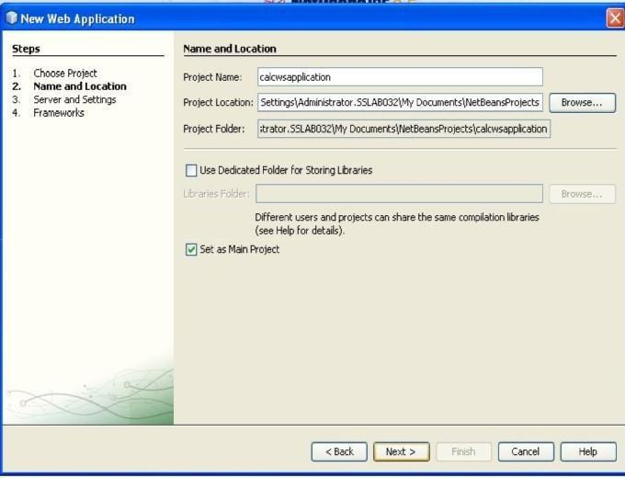

1. Right click calcwsapplication and select New -> web serviceGive web service name as calwebserviceand package name as calculator and click Finish
2. Expand web service folder.Right click calwebservice and click Add Operation,Give operation nameas add and return type as int
3. Click add button and give parameter as a and data type as int .Again Click add button and giveparameter name as b and its data type as b and Click OK

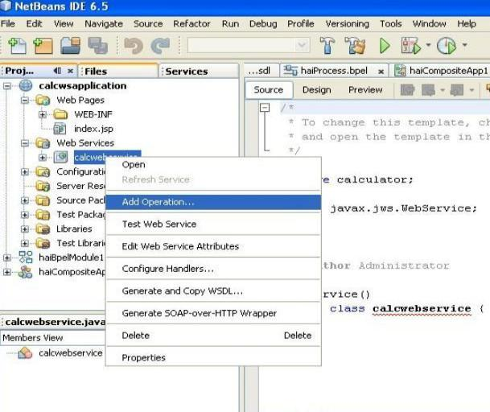

**Step 6 and 7:**

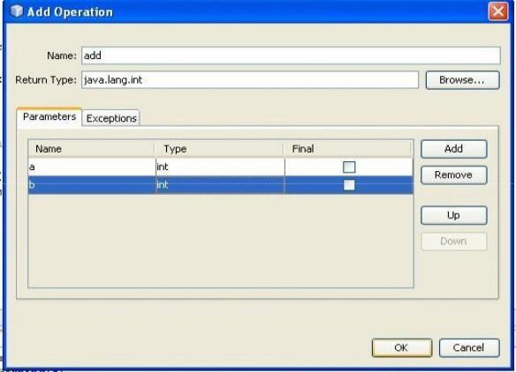

1. Instead of return 0, change it as return a+b

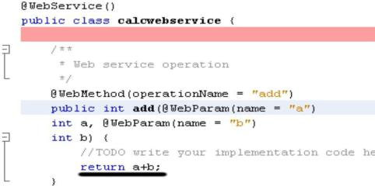

1. Similarly, add operations for subtraction(sub), multiplication(mul),division(div)
2. Right Click calwsapplication and click clean and build.It will show BUILDSUCCESSFUL.
3. Again right Click calwsapplication and click deploy.It will show BUILD SUCCESSFUL.

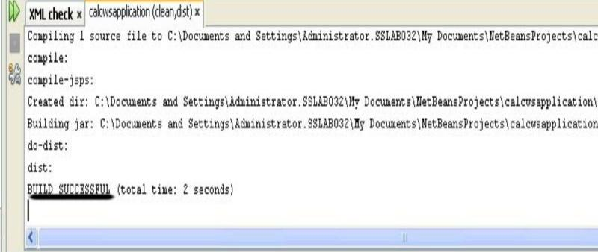

1. Select calwsapplication -> web services -> calculatorws.Right click and select Test WebService
2. Give input values and click add button to check output

Go to back and click WSDL to open it. Now, Server is running...

**Web Service tester page:**

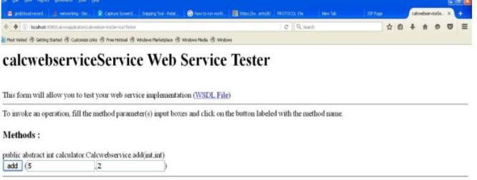

**Output:**

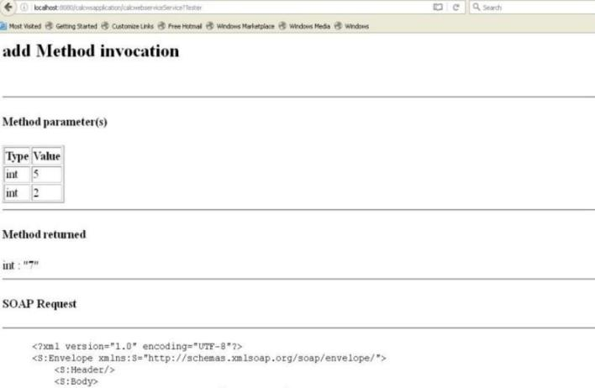

**Invoking Web Service Client**

1. Click File -> New Project.Select web application from java web category
2. Give file name as calcwsclient.click next and then finish.
3. Right Click calcwsclient and Select New -> web service client

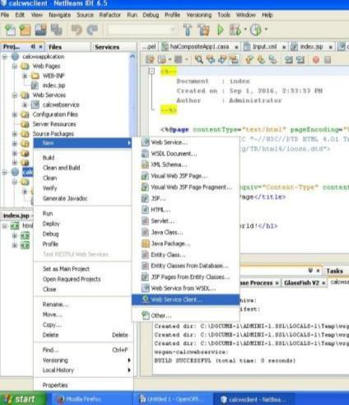

1. Select Project and click browse. Browse the web service that we did in the previous step. Ensure thatclient style is JAX- WS style.

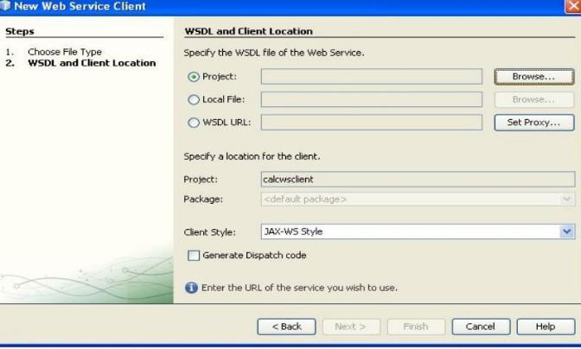

1. Click Finish.Code will appear and it will show some error
2. Click on error.At end of line add: xendorsed="true" and save it.
3. Right Click calcwsclient -> web pages and select new -> JSP
4. Give file name as client and click finish.
5. In client.jsp page, inside the body tag,remove h1 tag and drag and drop the add operationfrom web_service_references from calcwsclient

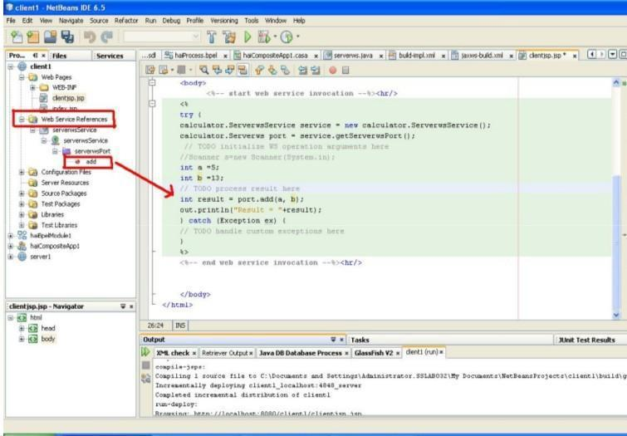

1. In the code appeared, change the values.(For instance, a=5,b=13)
2. Right Click calcwsclient and click Clean and build
3. Again Right click calcwsclient and click deploy.It will show BUILD SUCCESSFUL.
4. Right Client Client.jsp and click Run file
5. It will show the output as follows:

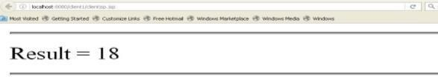

1. Similarly create jsp files for subtraction, multiplication and division.

**RESULT:**

Thus, calculator is implemented as a web service using SOAP protocol.

**DEVELOP A CLOUD ENVIRONMENT USING CLOUDSIM SIMULATOR**

**EX.NO : 2**

**AIM:** To install CloudSim and to implement the java code to create cloudlets and to execute the cloudlets in data centers.

**PROCEDURE:**

1. Open the eclipse tool using the path **E:\cloud grid\eclipse-**

**SDK-4.2.2-win32x86_64\eclipse\eclipse.exe**

1. Click on File Menu → New → Java Project

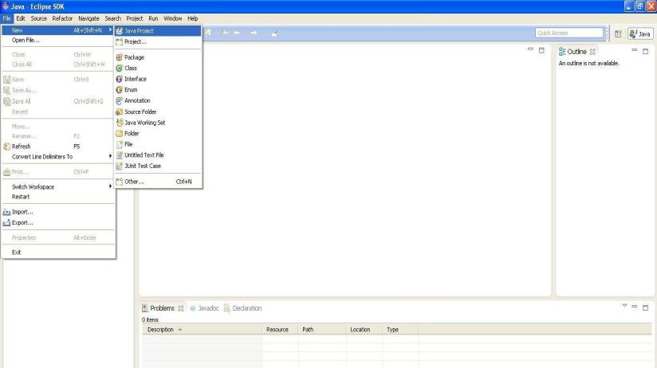

1. Give name to the project (for instance, cloud1) and click on **Next** Button

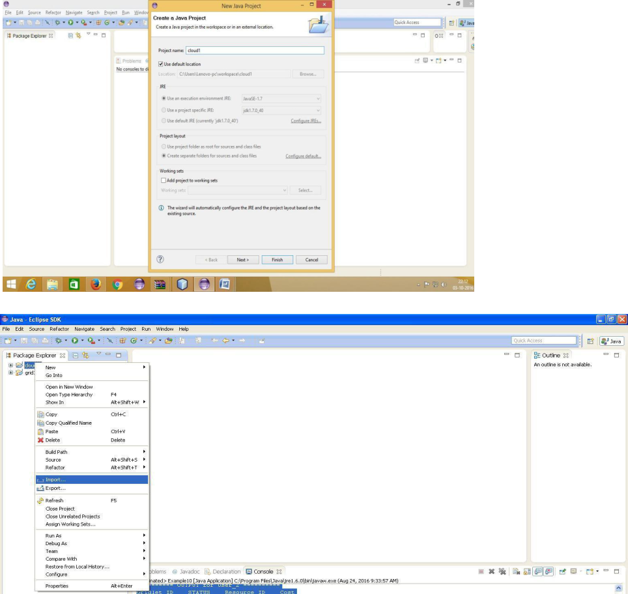

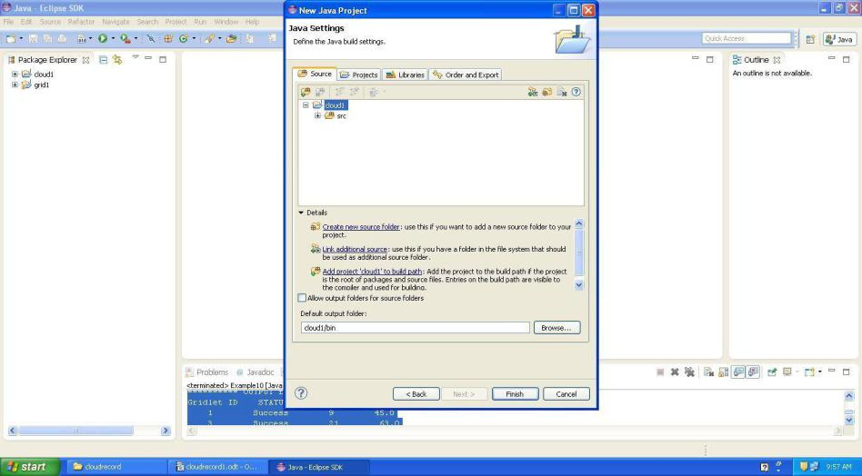

1. Click **Finish** Button
2. Right Click on the project in project explorer and click **Import**
3. Select General → File System and click Next
4. Click **Browse** and browse the CloudSim-3.0.3 folder and Select the folder.

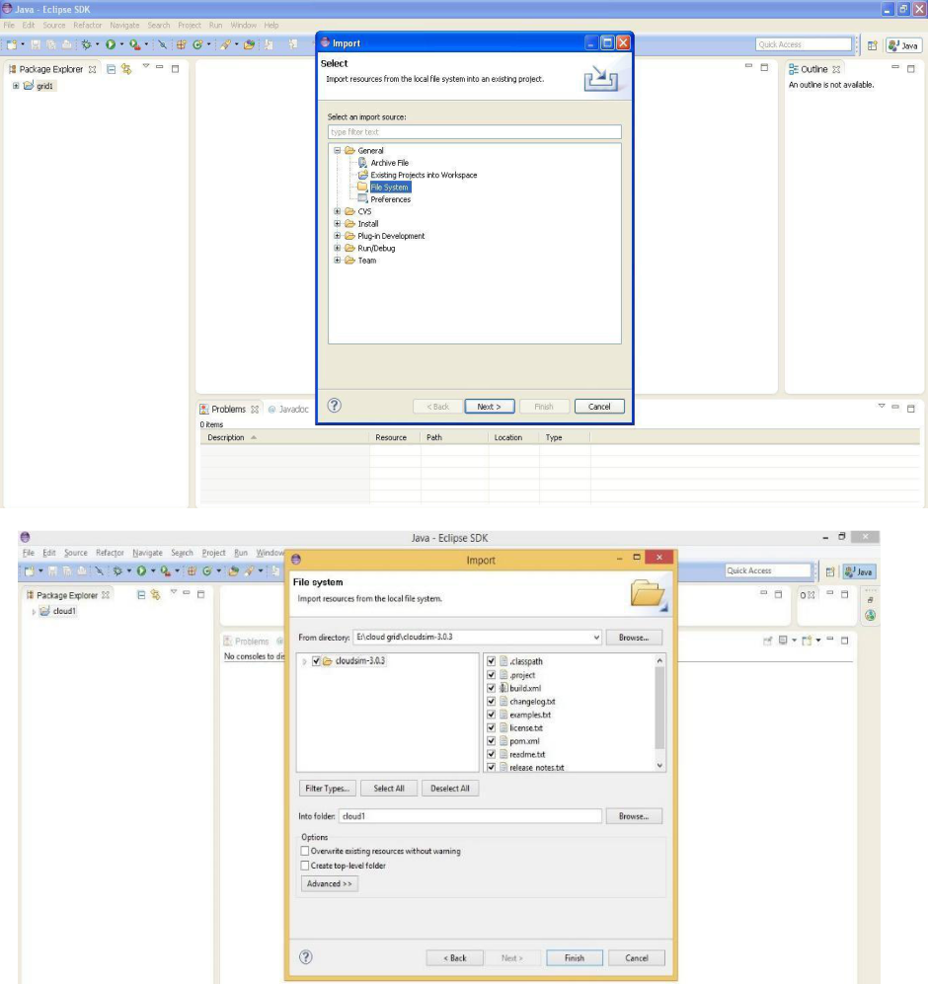

1. Click OK
2. Then Select the CloudSim folder

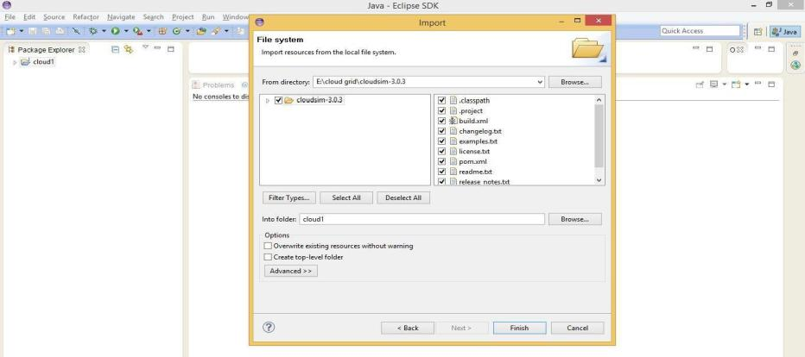

1. Click **Finish** Button

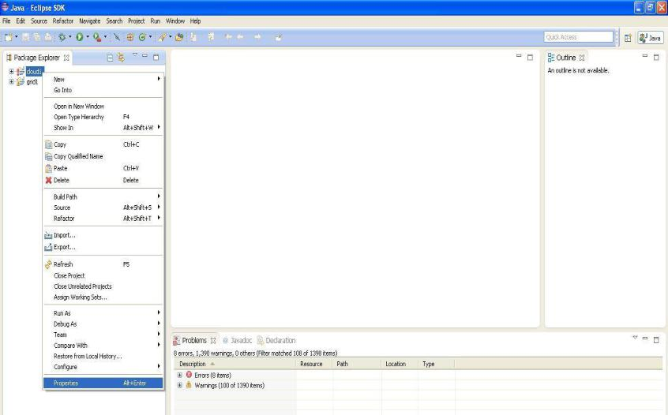

1. Click **yes to All** to import
2. Right Click the project in project explorer and click **properties**
3. Click on **Java Build Path** and then **libraries** tab
4. Remove Error showing Jar files

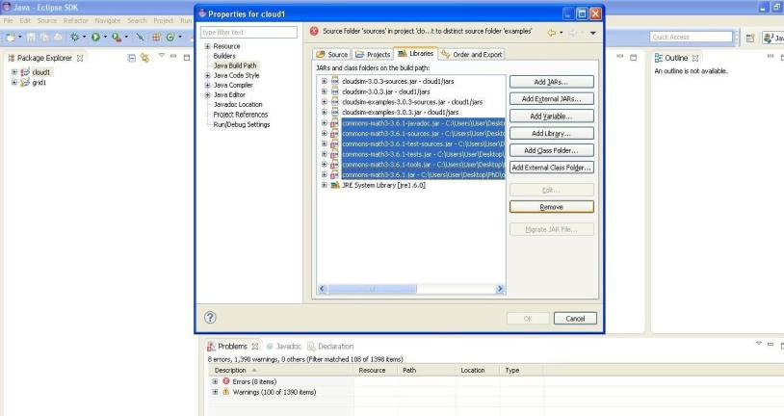

1. Click on **Add External Jars**
2. Browse and Select all the jar files within CloudSim folder → jars

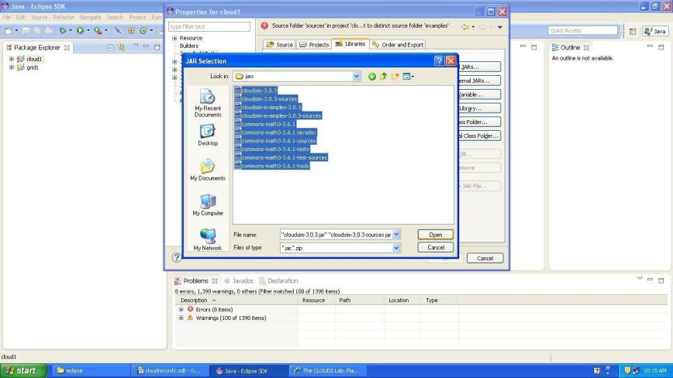

1. Again Click on Add External Jars to include common math jars

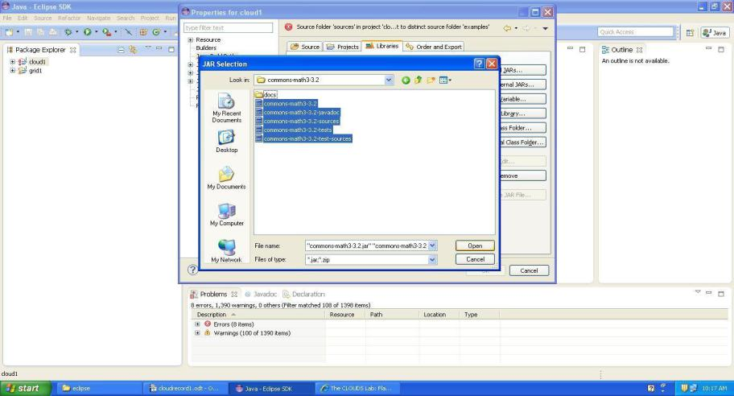

1. It will show Error. Click on Source tab and followed by **Browse** button
2. Click on C**reate New Folder**
3. Give folder name (for instance, output)
4. Click OK and again click OK
5. Expand the project and Navigate into cloud1 → examples → org.cloudbus.cloudSim.examples → CloudSimExample1.java
6. Open the source code by double clicking the CloudSim Example

Starting CloudSimExample3... Initialising...

Starting CloudSim version 3.0 Datacenter_0 is starting...

Broker is starting...

Entities started.

* Broker: Cloud Resource List received with 1 resource(s)
* Broker: Trying to Create VM #0 in Datacenter_00.0: Broker: Trying to Create VM #1 inDatacenter_0
* Broker: VM #0 has been created in Datacenter #2, Host #0
* Broker: VM #1 has been created in Datacenter #2, Host #1

0.1: Broker: Sending cloudlet 0 to VM #0

0.1: Broker: Sending cloudlet 1 to VM #1

80.1: Broker: Cloudlet 1 received

160.1: Broker: Cloudlet 0 received

160.1: Broker: All Cloudlets executed. Finishing... 160.1: Broker: Destroying VM #0

160.1: Broker: Destroying VM #1Broker is shutting down...

Simulation: No more future events

CloudInformationService: Notify all CloudSim entities for shutting down. Datacenter_0 is shutting down...

Broker is shutting down... Simulation completed.

Simulation completed.

========== OUTPUT ==========

Cloudlet IDSTATUS Data center ID

1 SUCCESS 2 1 80

0 SUCCESS 2 0 160 VM ID Time0.1 0.1

Start Time Finish Time 80.1 160.1

CloudSimExample3 finished!

**RESULT:**

Thus, cloud is simulated in CloudSim Environment and the program is execute

**PROCEDURE TO RUN A VIRTUAL MACHINE WITH DIFFERENT CONFIGURATION AND TO CHECK HOW MANY VIRTUAL MACHINES CAN BE UTILIZED AT A PARTICULAR TIME**

**EX.NO. : 3**

**AIM: Use Eucalyptus and to demonstrate the following and Find procedure to run the virtual machine of different configuration. Check how many virtual machines can be utilized at a particular time.**

**PROCEDURE:**

**STEP 1:**

Install the virtual machine (vmware workstation 12) Click **create new virtual machine.**

New virtual machine wizard dialog box appear, check the installer disk image file (iso). Browse the faststat1.3.4.2.iso file from the path **E:\Cloud Grid\ faststat1.3.4.2.iso**

Click **next**

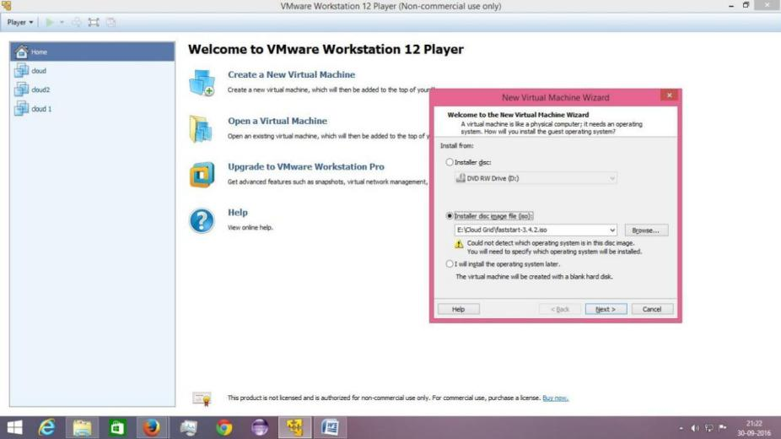

**STEP 2:**

Select the **LINUX** operating system. Version: **CENTOS 64-bit**

Click **next**

Create a virtual machine name as **cloud**(any name).

Browse the location for the virtual machine **E:\cloudgrid** To make the folder,click browse 2.select **E:**

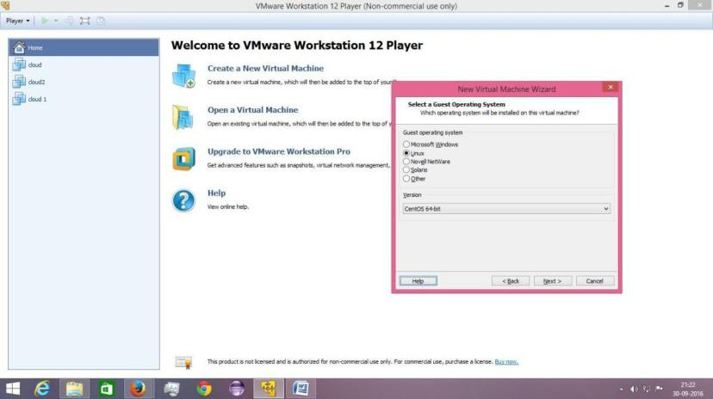

Click **make new folder** Give the name for folder

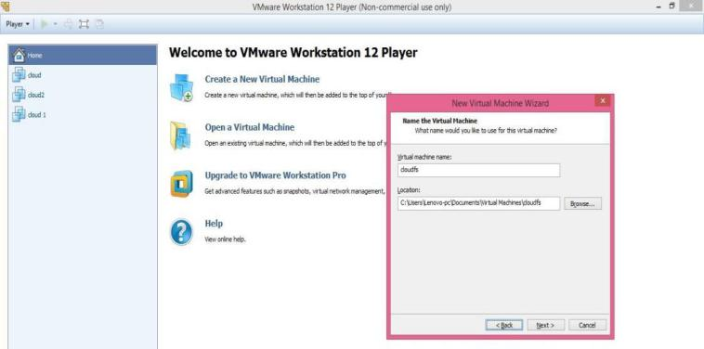

**STEP 4:**

Set maximum disk size as **40 GB.**

Select the **“Store virtual disk as single file”**option. Click **next**

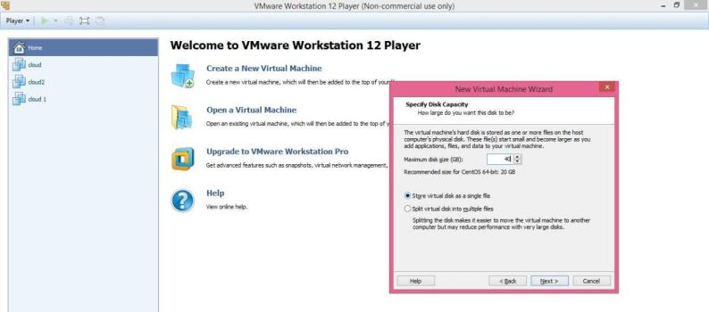

**STEP 5:**

Select the **“customize hardware option”.** Select Memory as **4GB.**

Select number of processors as 2 and select the two options **"Virtualize Intel" and "Virtualize CPU".**

Click **close** when all changes are done.

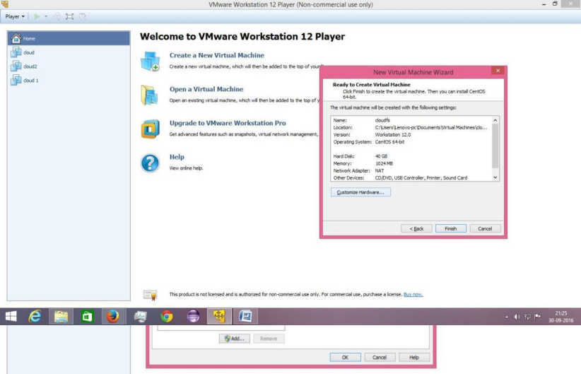

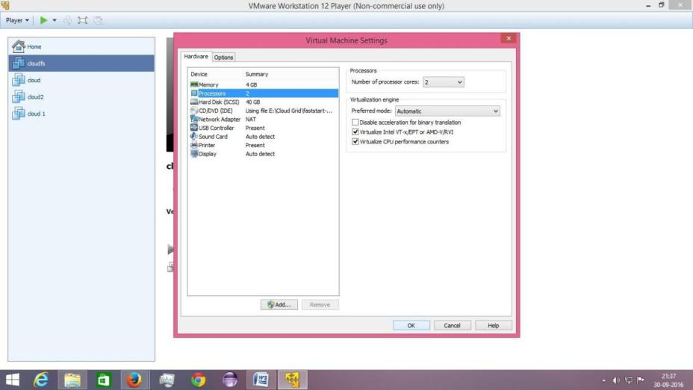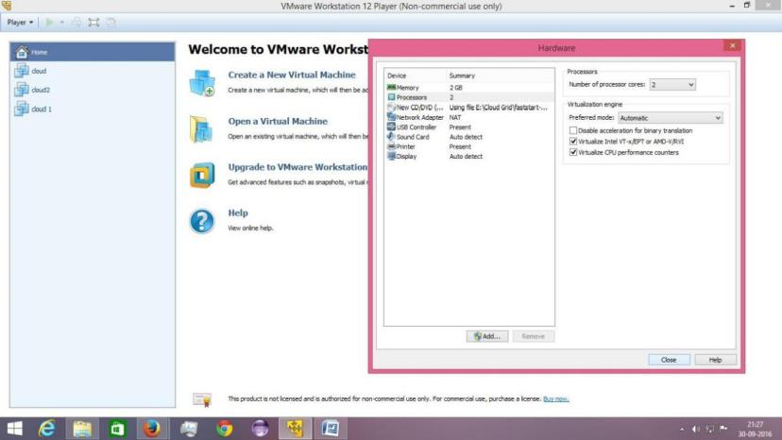

**STEP 6:**

1. Click **"Finish"** on the next Screen.

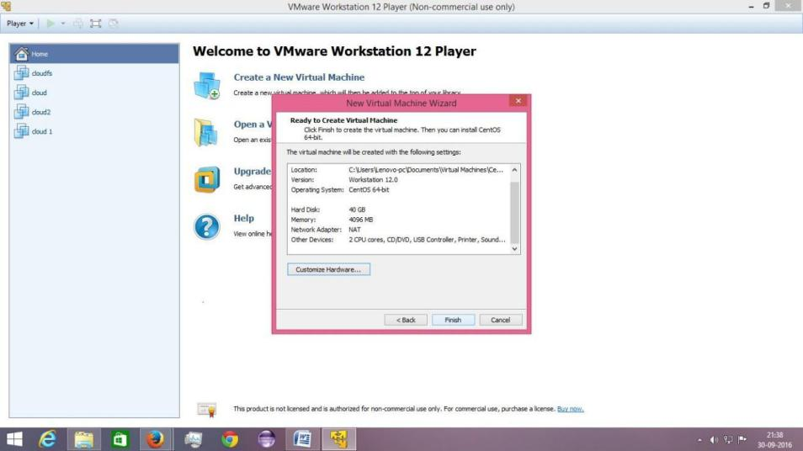

**STEP 7**

Select the recently created virtual image and click on **"Play Virtual Machine**

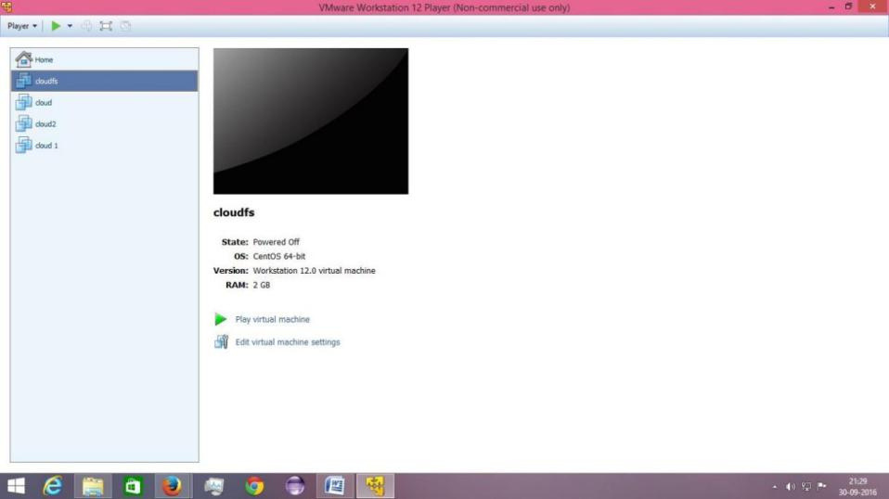

**STEP 8:**



Click on **"Install CentOS 6 with Eucalyptus Cloud-in-a-box".**

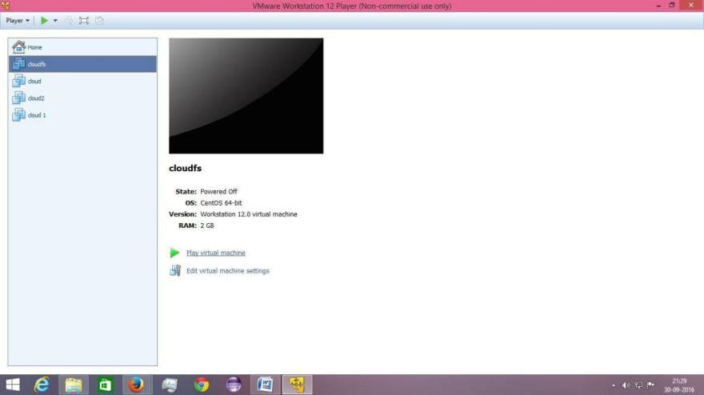

**STEP 9:**

Click on **"Skip"** in the screen which asks for media test.

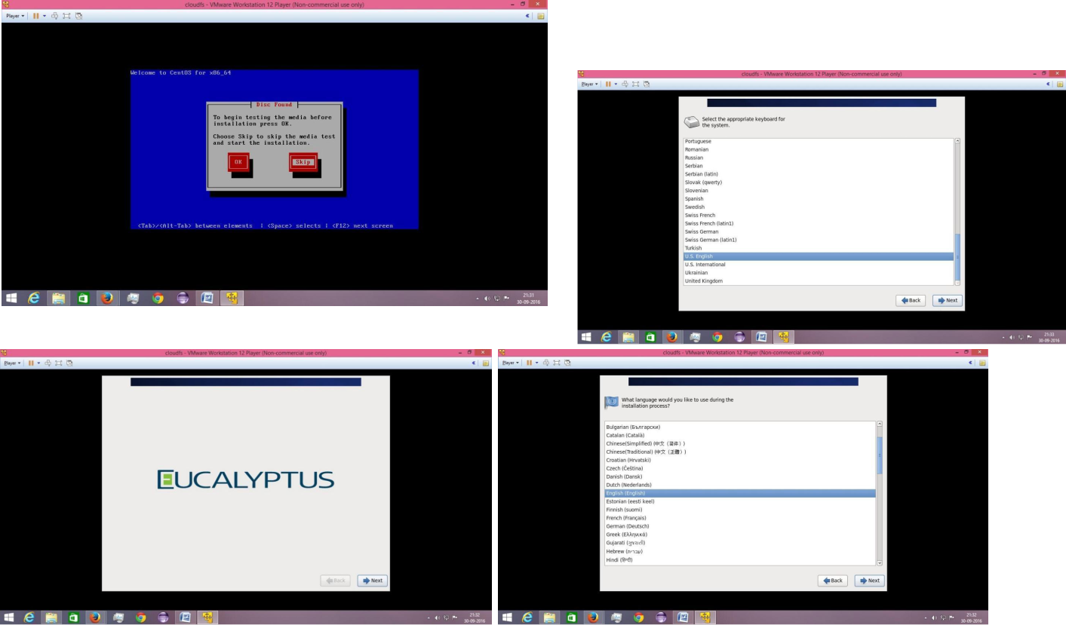

**Step 10:**

Click On **"Next"** in the previous screens till you arrive at **a Storage Device Warning**. Click on **"Yes, Discard any data".**

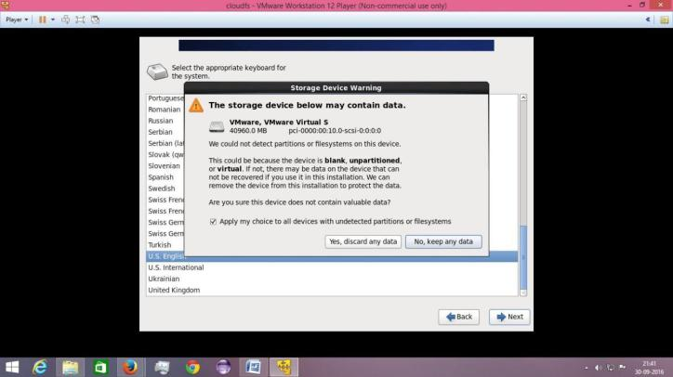

**STEP 11:**

Select hostname as **"root".**

Select Network Interface as **"eth0"** and mode as **"Static".**

Enter the IP Address as **"192.168.12.201"** and Netmask **"255.255.255.0".** Enter Default Gateway as **"192.168.12.1"** and DNS as **"8.8.8.8".**

Click **Next.**

Select city as **"Kolkota/Asia".** Click **Next.**

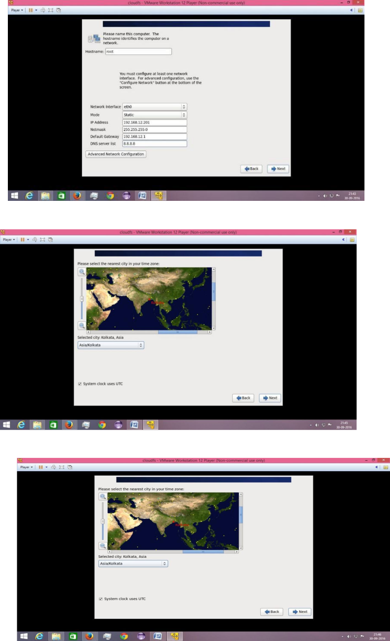

**STEP 12:**

Enter your **root password:123456** and click **Next.** Click on **"Use Anyway".**

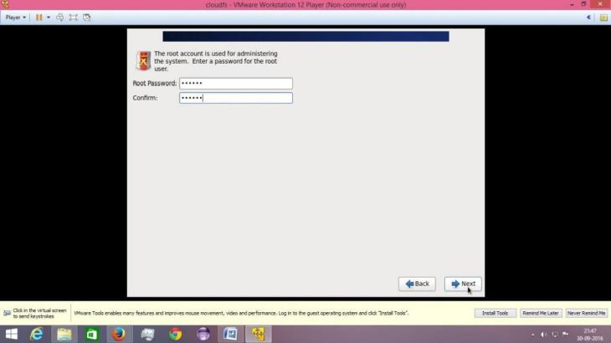

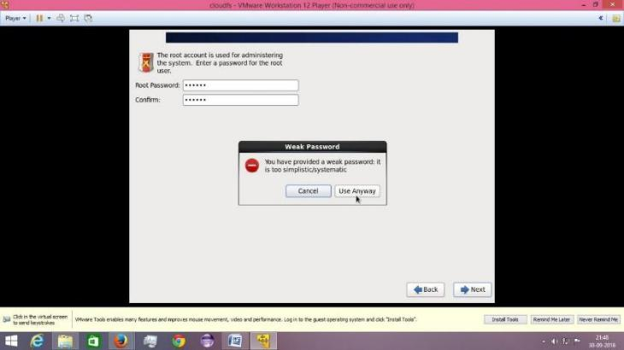

**STEP 13:**

Enter the Public IP range as **"192.168.12.202-192.168.12.210".** Click on **Next**

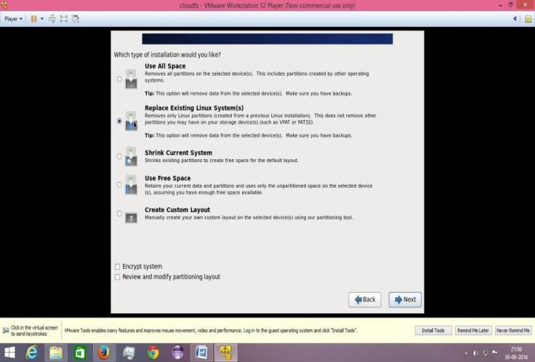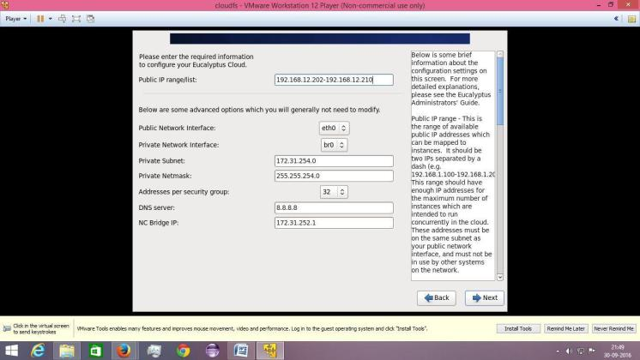

**STEP 14:**

Select **Replace Existing Linux Systems** and click on **Next.**

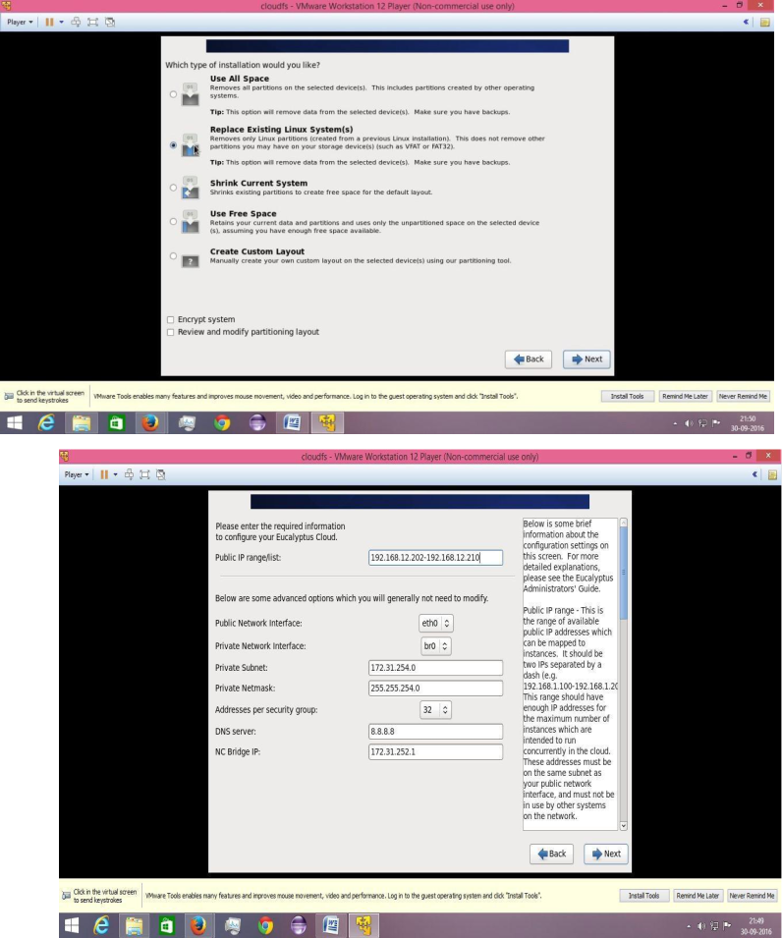

**STEP 15:**

Click on **Write Changes to Disk.**

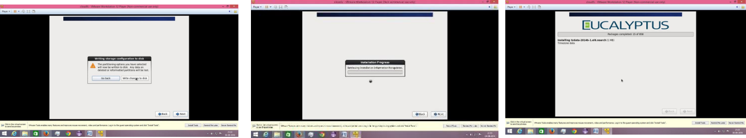

Wait for installation to complete

**STEP 16:**

Click on **Reboot.**

Wait for CentOS to boot up.

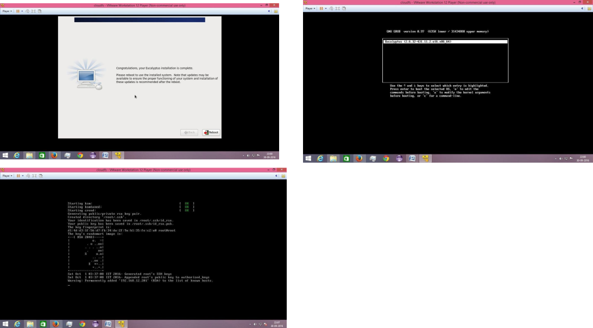

**STEP 17:**

Click on **Forward.**

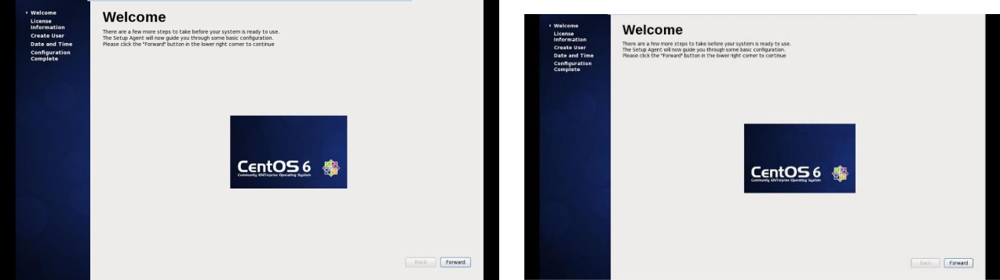

**STEP 18:**

Type your Username**:user,** FullName**:user,** Password**:user and** Confirm Password**:user.**

Click on **Forward** when you are done. Select **"Yes"** if dialog box appears.

Click **Forward** and **Finish** when Configuration Complete Window appears.

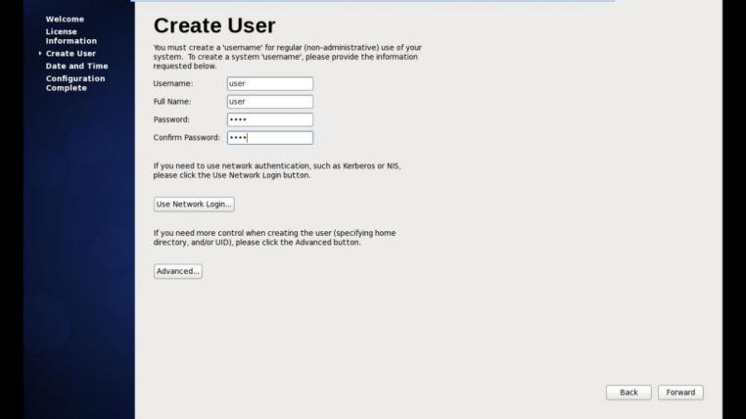

**STEP 19:**

Enter your password and Login into the system. User name:user

Password:user

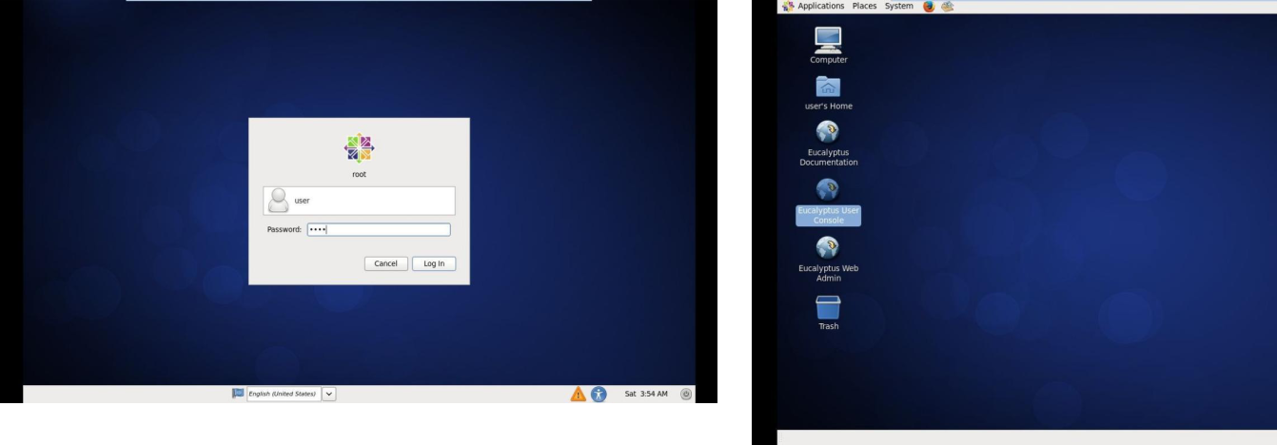

**STEP 20:**

Open Firefox and go to the URL - **"192.168.12.201:8888"** ( Or) click the eucalyptus user console

Click on **"I Understand the Risks"** and then click on **"Add Exception".** Click on **"Confirm Security Exception".**

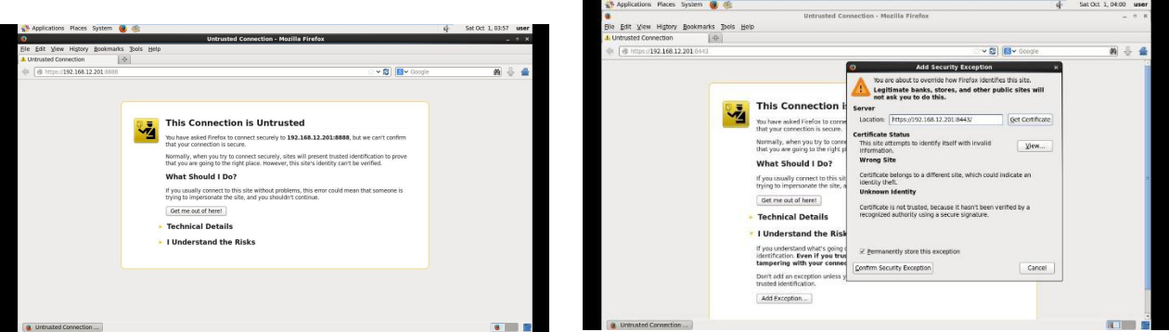

**STEP 21:**

Log into the Eucalyptus

**Account name:demo, username: admin , password: 123456** Click on **"Launch new Instance"**

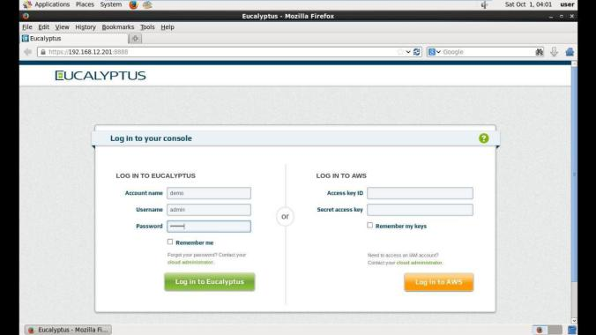

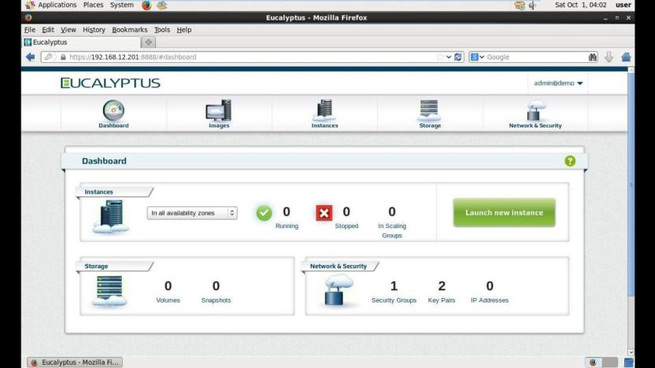

**STEP 22:**

**Select the Image** to be used.

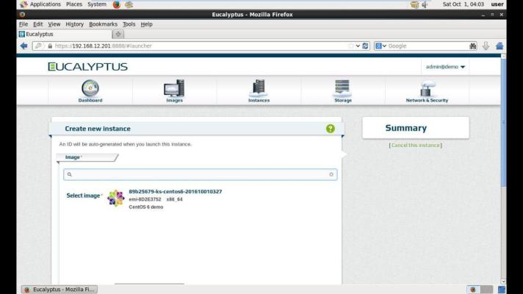

**STEP 23:**

Select the **"Select Type".**

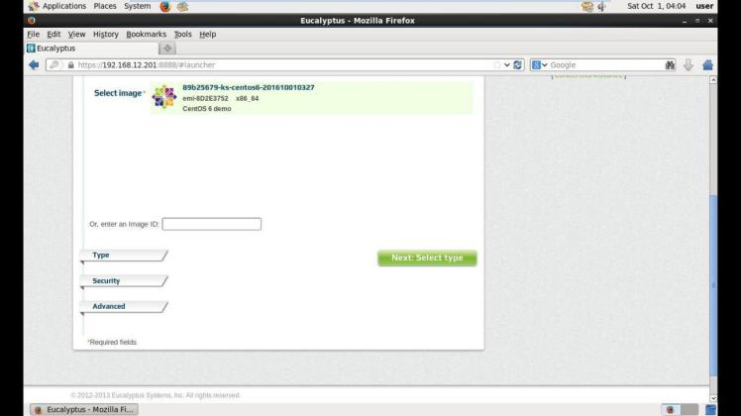

**STEP 24:**

Select the **"Select Security".**

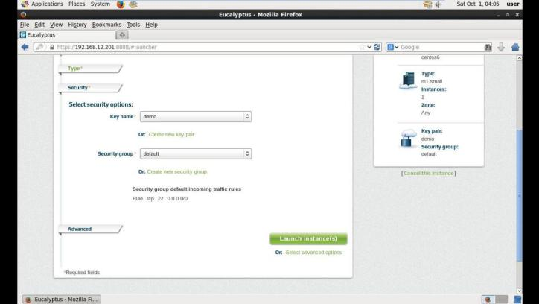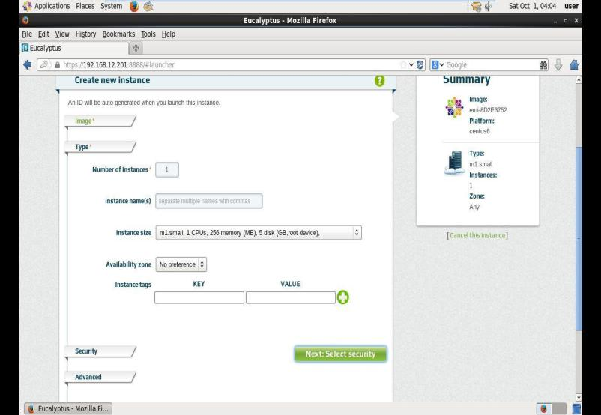

**STEP 25:**

Select the **"Create new key pair".**

**Give a name** for your key pair and click on create and download and then on **"Save**

**.pem File"** on the window that appears.

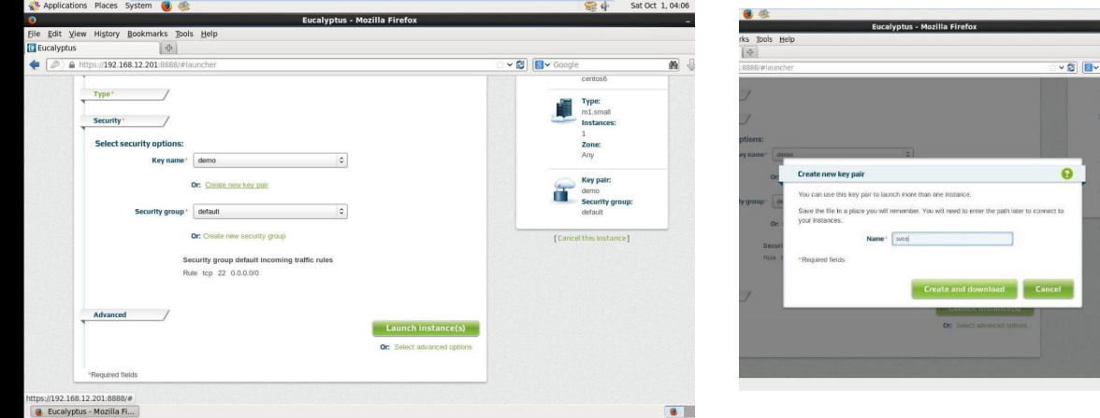

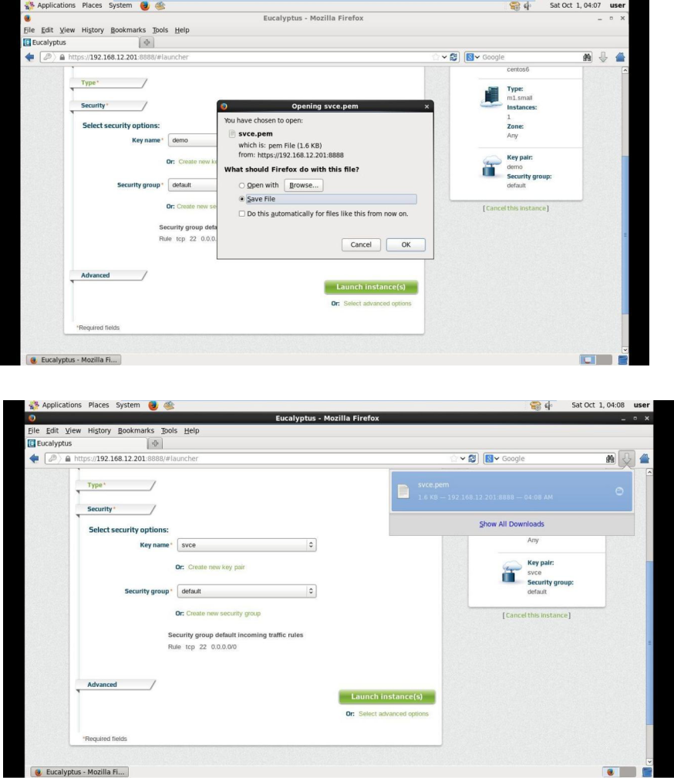

**STEP 26:**

Select the **"Create new Security Group".**

Enter name as **svce** and description as **"Hello".**

Select **Rules Tab** and create a rule for the **SSH protocol**

Enter IP address as **"192.168.12.202/32" (or)click use my ip** and click on

**"Create Group".**

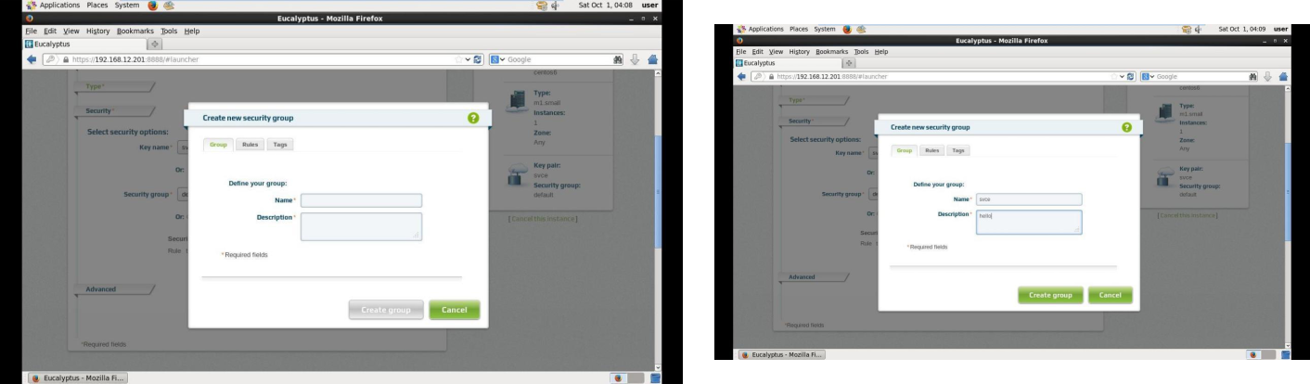

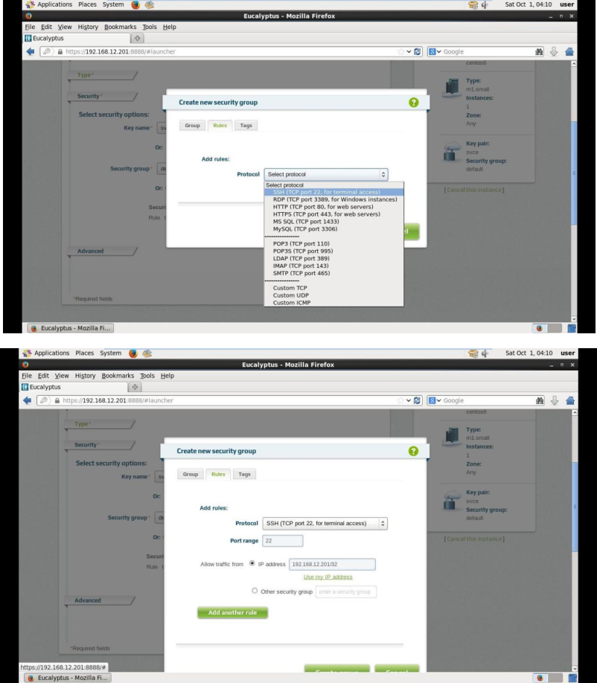

**STEP 27:**

Click **on Launch Instance** and wait for the instance for launching.

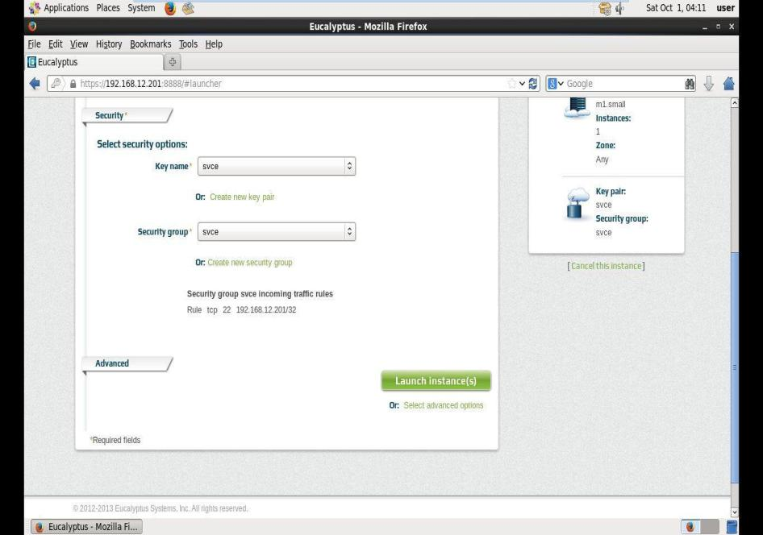

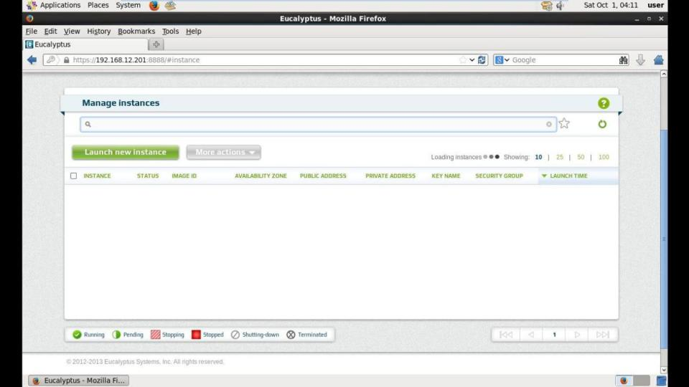

**STEP 28:**

Open a new Terminal. Type the following

**1.cd Downloads 2.ls**

(This list all the files from the downloads)

1. **chmod 400 svce.pem**
2. **ssh -i svce.pem** [**cloud-user@192.168.12.202**](mailto:cloud-user@192.168.12.202) **5.lsblk**

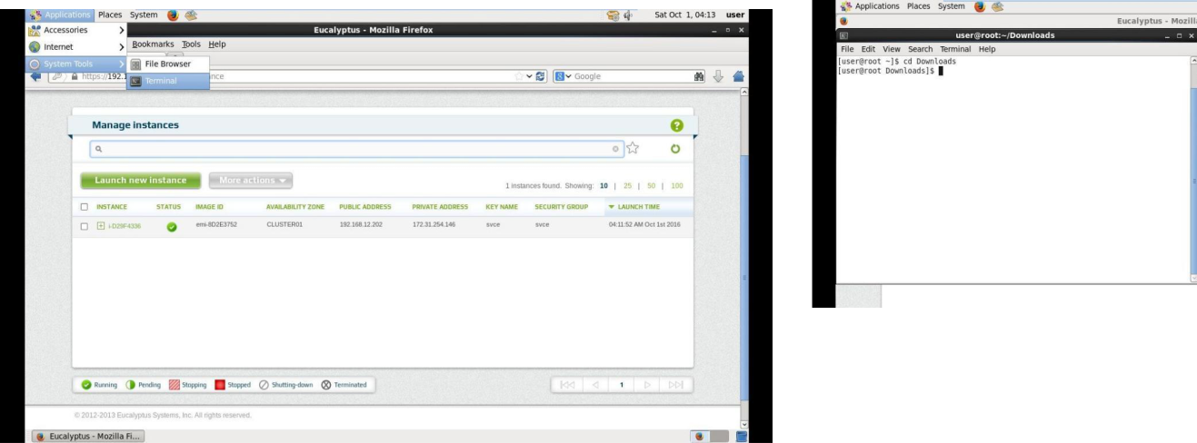

**Result:** Thus the Eucalyptus is installed and used to run the virtual machine of different configuration and instance creation has been executed successfully.

**PROCEDURE TO ATTACH A VIRTUAL BLOCK TO THE VIRTUAL MACHINE AND CHECK WHETHER IT HOLDS DATA EVEN AFTER THE RELEASE OF THE VIRTUAL MACHINE**

**EX.NO. : 4**

**AIM: To attach a virtual block to the virtual machine and check whether it holds the data even after the release of the virtual machine.**

**PROCEDURE:**

**STEP 1:**

1.create the **virtual machine installed** with centos.

2.create an **instance**(follow the previous exercise step).

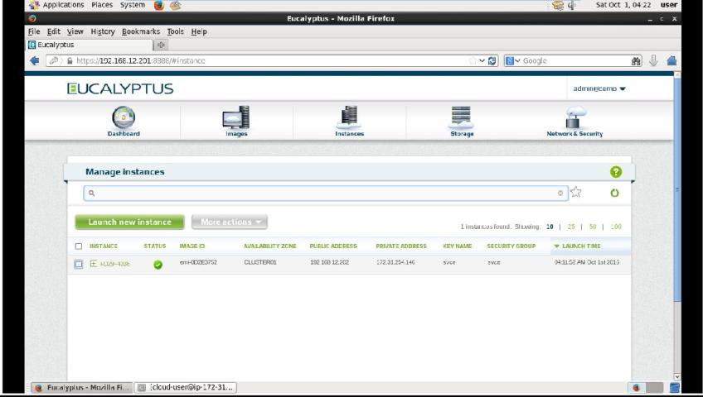

**STEP 2:**

1. Click **Storage** and select **volume.**
2. Click **create new volume.**

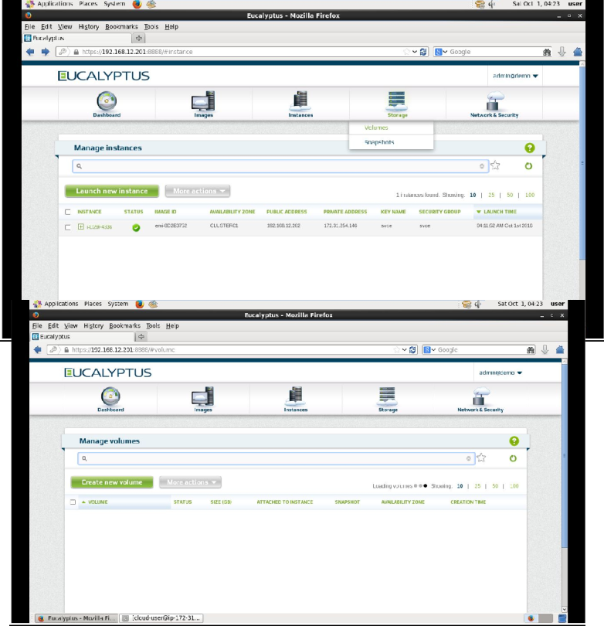

**STEP 3:**

1. Create new volume dialog box will appear
2. Click general tab
3. Enter name : any name
4. Create from snapshot : none
5. Volume size : 1GB
6. Availability zone :cluster 01
7. Click create volume

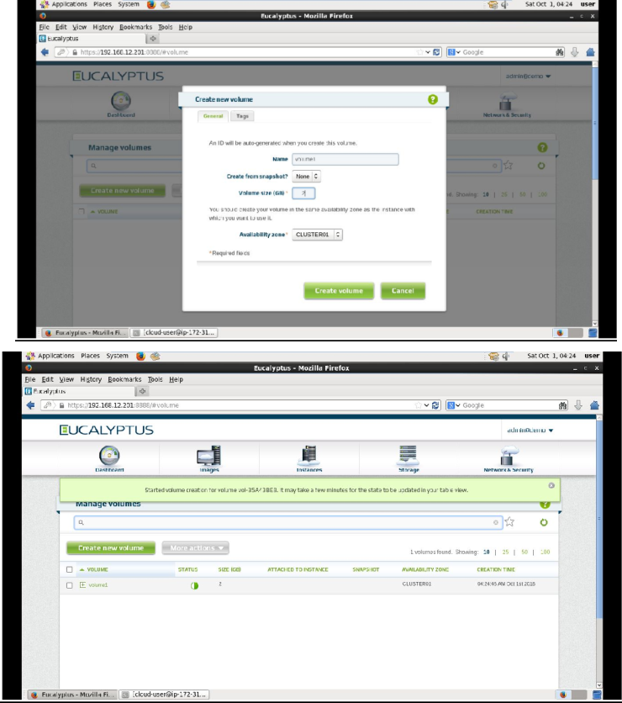

**STEP 4:**

1. After volume is created successfully click more actions button
2. Select attach to instance from drop down menu.
3. Attach volume to instance dialog box will appear

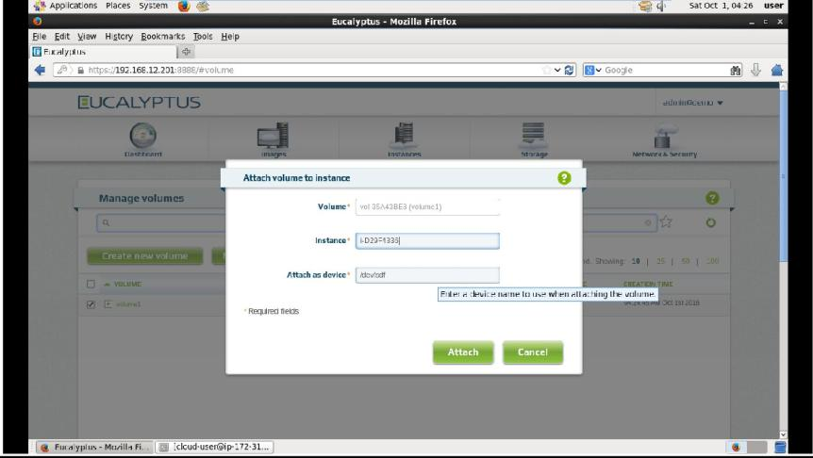

1. Ensure value is Entered for volume name, Instance(select from dropdown the instace which was created),attach as volume (/dev/sda).
2. Click attach.

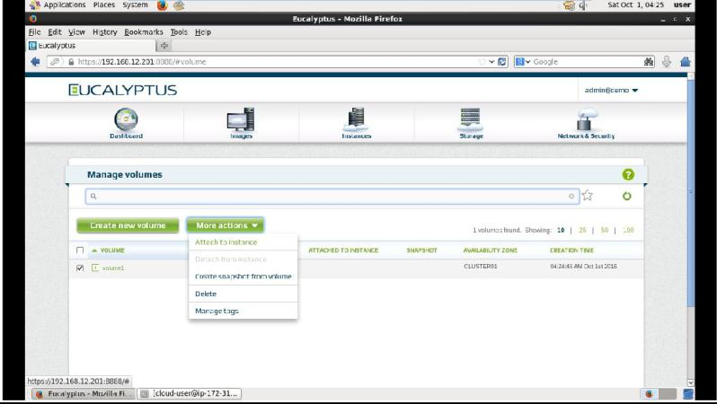

**STEP 5:**

1.Ensure the status is in “in use”.

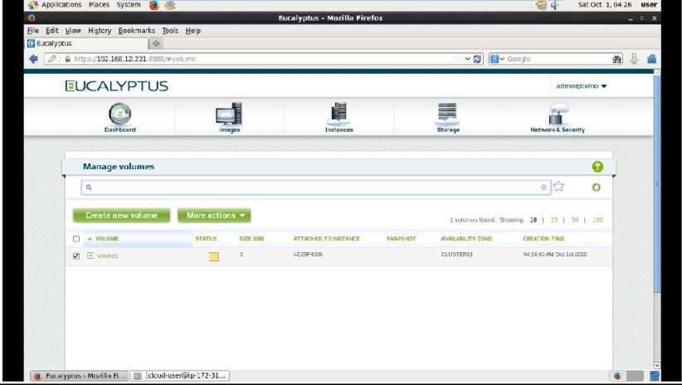

**STEP 6:**

1. open terminal 2.Type the following

cd Downloads ls chmod 400 svce.pem

ssh -i svce.pem [cloud-user@192.168.12.202](mailto:cloud-user@192.168.12.202) lsblk

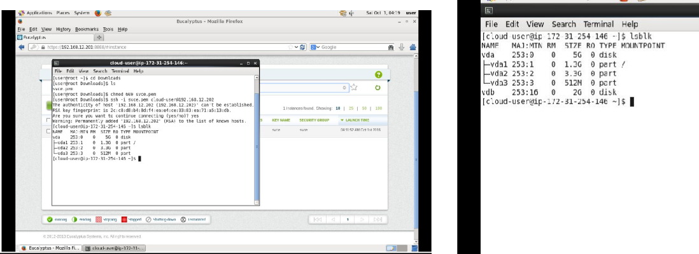

**RESULT: Thus the volume has been successfully attached to the instance created and verified whether it holds the data even after the release of the virtual machine.**

**USE EUCALYPTUS AND CREATE AN IMAGE AND EXECUTE THE INSTANCE**

**WITH A STORAGE CONTROLLER AND INTERACT WITH IT**

**EX.NO. : 5**

**AIM: To create a virtual image execute the instance with a storage controller and interact with it.**

**PROCEDURE:**

**STEP 1:**

* Open new terminal
* Type the following

**Creating the kernel image:**

source credentials/admin/eucarc

euca-bundle-image –i ~/Desktop/Eucaimage/ vmlinuz-2.6.32 642.3.1.el6.x86_64 -r x86_64 - -kernel true

After this step the following will be created /var/tmp/bundle-hfWXvk/ vmlinuz-2.6.32-642.3.1.el6.x86_64.manifest.xml

euca-upload-bundle -b kerimg -m /var/tmp/bundle-hfWXvk/ vmlinuz- 2.6.32-642.3.1.el6.x86_64.manifest.xml

(Note: kerimg is the user defined name/var/tmp/bundle-hfWXvk/ vmlinuz-2.6.32-642.3.1.el6.x86_64.manifest.xml

which is created under the bundle step (i.e)2)

After this step the following wil be created/vmlinuz-2.6.32- 642.3.1.el6.x86_64.manifest.xml)

1. **euca-register kerimg/vmlinuz-2.6.32-642.3.1.el6.x86_64.manifest.xml -a x86_64 -n gcckernel**

**(Note:** /vmlinuz-2.6.32-642.3.1.el6.x86_64.manifest.xml which is created under upload step (i.e) 3. Gcckernel is also user defined name.The two user defined names should not be same)

1. **EKI image will be created eki-6SD039D3(refer the screen shot) Screenshot for creating kernel image(eki image)**

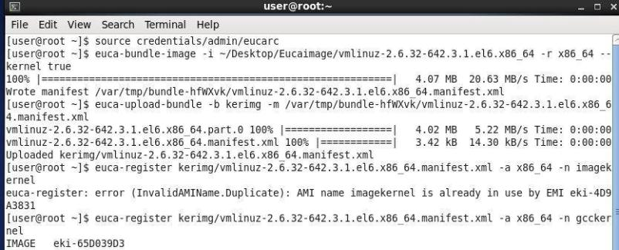

**STEP 2:**

**Creating the RAM image:**

Type the following in the same terminal

**5. euca-bundle-image -i ~/Desktop/Eucaimage/initramfs-2.6.32-642.3.1.el6.x86_64.img -r** **x86_64**

**- - ramdisk** **true**

After this step the following will be created /var/tmp/bundle-PnF6Y4/initramfs-2.6.32-642.3.1.el6.x86_64.img.manifest.xml

1. **euca-upload-bundle -b ramimg/var/tmp/bundle-PnF6Y4/initramfs- 2.6.32-642.3.1.el6.x86_64.img.manifest.xml**

(Note: ramimg is the user defined name

**/**var/tmp/bundle-PnF6Y4/initramfs-2.6.32-642.3.1.el6.x86_64.img.manifest.xml which is created under

the bundle step (i.e)1)

After this step the following wil be createdramimg/initramfs- 2.6.32- 42.3.1.el6.x86_64.img.manifest.xml**)**

1. **euca-register ramimg/initramfs-2.6.32-642.3.1.el6.x86_64.img.manifest.xml -n gccram -a x86_64**

**(Note:** /initramfs-2.6.32-642.3.1.el6.x86_64.img.manifest.xml which is created under upload step (i.e) 2.gccram is also user defined name. The two user defined names should not be same)

1. ERI image will be created **eri-67F9346B3(refer the screen shot)**

**Screenshot for creating RAM image(eri image)**

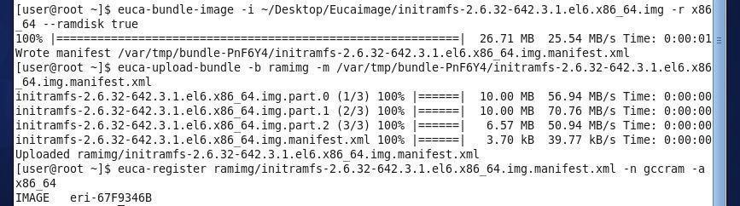

**STEP 3:**

**Creating the MANIFEST image:**

**euca-bundle-image-i** ~/Desktop/Eucaimage/root1.img -r x86_64 - - kernel eki- 6SD039D3 - -ramdisk eri-67F9346B3

After this step the following will be created /var/tmp/bundle Z61gwm/root1.img.manifest.xml euca-upload-bundle-b rootimg -m /var/tmp/bundle-Z61gwm /root1.img.manifest.xml

(Note: rootimg is the user defined name /var/tmp/bundle-Z61gwm /root1.img.manifest.xml which is created under the bundle step (i.e)1) After this step the following wil be created rootimg/root1.img.manifest.xml**)**

euca-register **rootimg/root1.img.manifest.xml -n gccroot -a x86_64 (Note:**

rootimg/root1.img.manifest.xml which is created under upload step (i.e) 2. gccroot is also user defined name.

The two user defined names should not be same)

EMI image will be created **emi-3E633FB3(refer the screen shot) Screenshot for creating MANIFEST image(emi image)**

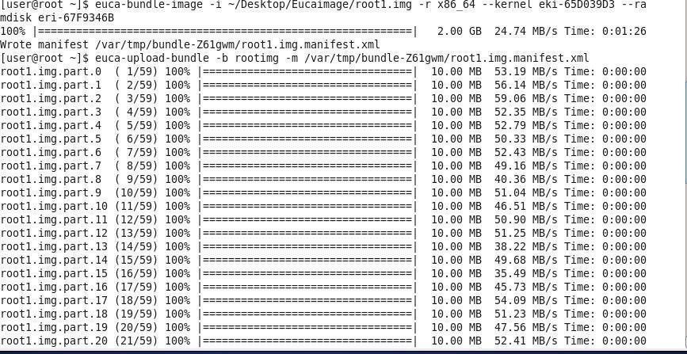

**STEP 4:**

This EMI image can be accessed only by the ADMIN.

This access privilege can be extended to all user by the following steps.

euca-modify-image-attribute -l –a all emi- 3E633FB3 (launch permission will be given to all groups)

euca-modify-image-attribute - -description GCC emi-3E633FB3 (description name is assigned to emi image. GCC is user defined name Refer the screenshot)

**Screenshot for launch permission**

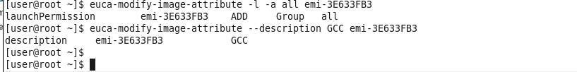

**STEP 5:**

* Open browser and type**:** https://192.168.12.201:8888 (or) click the eucalyptus user console directly.
* Click Create new instance

3 You will find two image

centos6 demo(already existed image) 2.gccroot( created image)

* For creating an instance follow the procedure of eucalyptus instance creation,instead of selecting centos 6 demo **select gccroot**

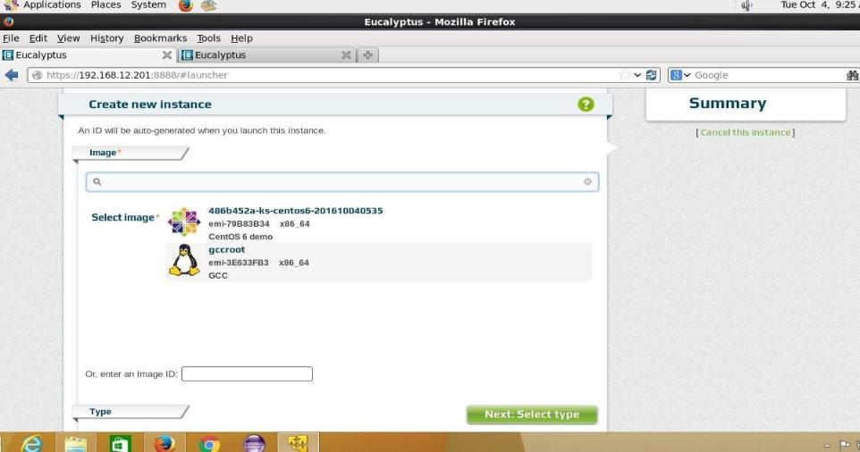

**STEP 6:**

* Give instance name, instance size.
* Next select security type where you will click.

1. create new pair(create and download it)

6.1 create new security group(create group and assign rules to it)

* Click launch instance.

8 Instance will be created.

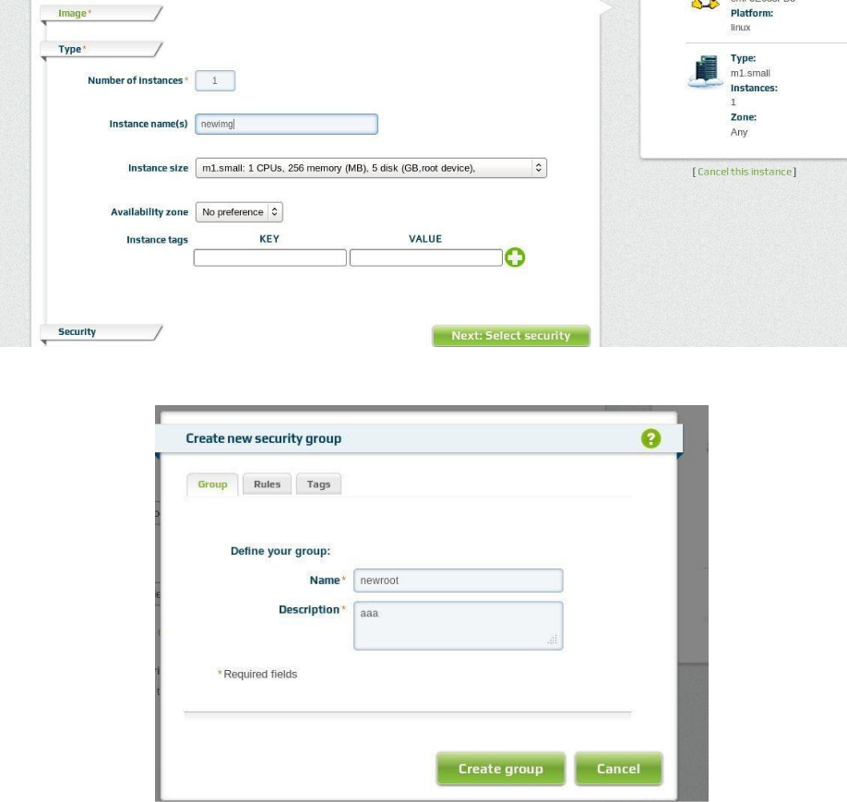

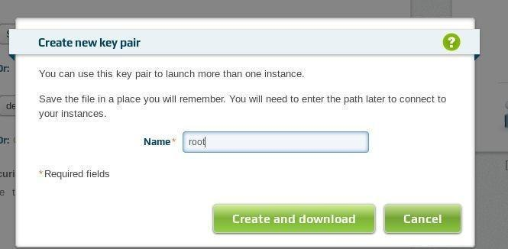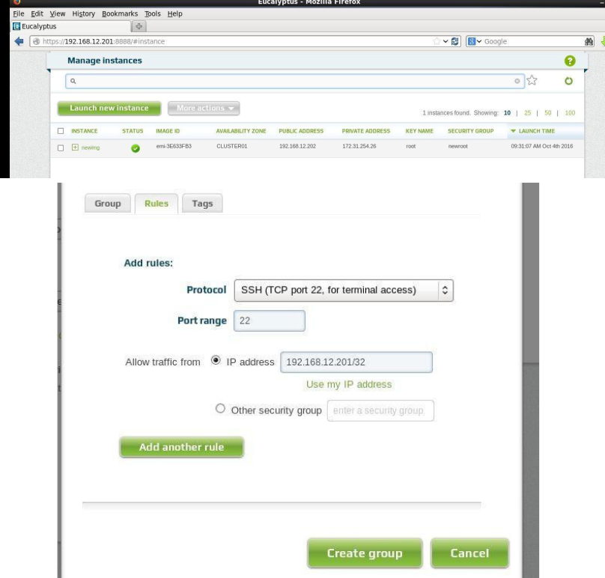

**STEP 7:**

Open terminal

Type the following

**1.Ping 192.168.12.202**

(check whether public address is establish connection)

**chmod 400 root.pem (changing the permission of pem file which is created when instance launched)**

**ssh -i root.pem** [**centos@192.168.12.202**](mailto:centos@192.168.12.202) **Su -**

**Password: centos**

(It changes from user to root)

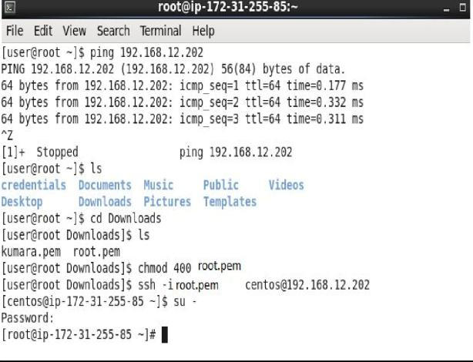

**RESULT : Thus an image is created and the instance is executed with a storage controller and interact with it**

**INSTALL A C COMPILER IN THE VIRTUAL MACHINE AND EXECUTE A SAMPLE PROGRAM EX.NO. : 6**

**AIM: To install a C compiler in the virtual machine and execute a sample program**

**PROCEDURE:**

**Step 1: Installation of GCC compiler**

**1.Yum install gcc**

(GCC will be installed from the local repository. After completion of gcc compiler,ready to run the C program)

To run the C program

Open the terminal

Execute the c program

* vi programname.c (for opening the program)
* Press esc:wq (saving the program

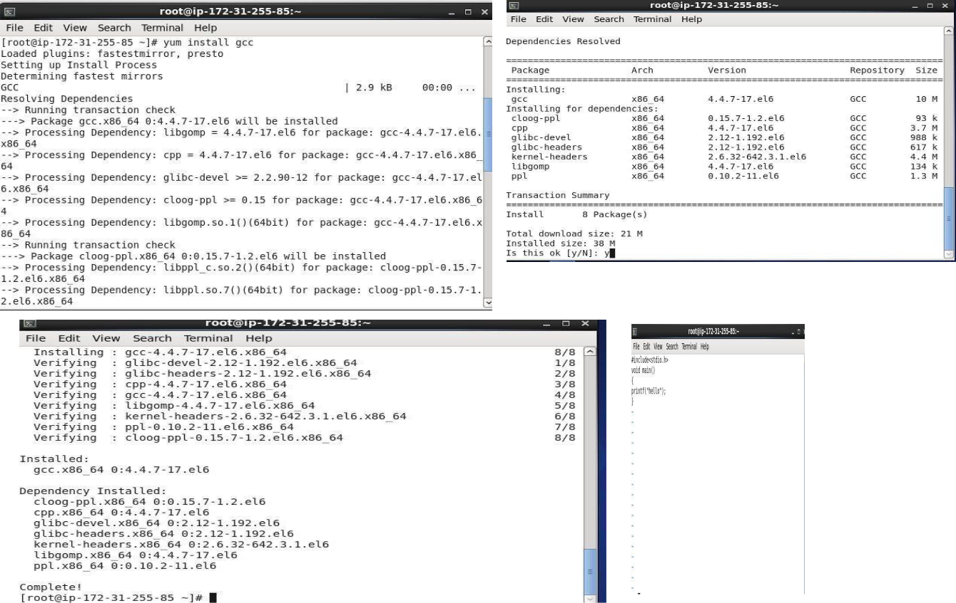

* cc programname.c (for compiling the program)

./a.out (to see the utput)

**Result:**

Thus the image(gcc) has been created and the C program has been compiled successfully.

**FIND THE PROCEDURE TO SET UP THE ONE NODE HADOOP CLUSTER:**

**EX.NO. : 7**

**AIM:**To find procedure to set up the one node hadoop cluster.

**PROCEDURE:**

**STEP 1:**

These softwares should be prepared to install Hadoop 2.8.0 on window 10 64bit Download Hadoop 2.8.0 (Link: [http://www](http://www/)-

eu.apache.org/dist/hadoop/common/hadoop-2.8.0/hadoop-2.8.0.tar.gz OR

[http://archive.apache.org/dist/hadoop/core//hadoop-2.8.0/hadoop- 2.8.0.tar.gz](http://archive.apache.org/dist/hadoop/core/hadoop-2.8.0/hadoop-2.8.0.tar.gz))

Java JDK 1.8.0.zip (Link:

<http://www.oracle.com/technetwork/java/javase/downloads/jdk8>-downloads-

2133151.html)

**STEP 2:**

**Check either Java 1.8.0 is already installed on your system or not, use "Javac - version" to check. java version**

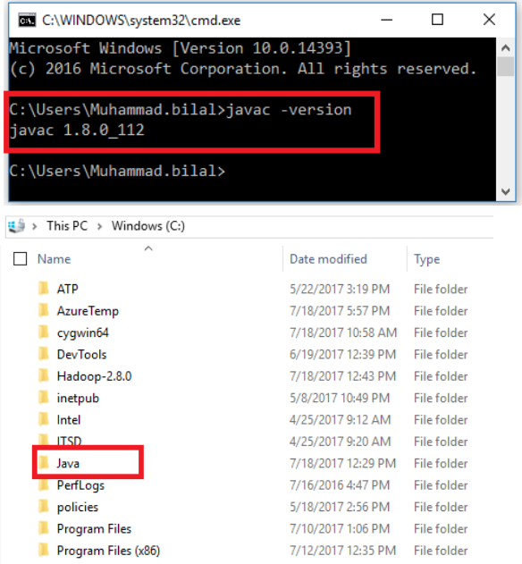

**If Java is not installed on your system then first install java under "C:\JAVA" Java setup**

**Extract file Hadoop 2.8.0.tar.gz or Hadoop-2.8.0.zip and place under "C:\Hadoop-**

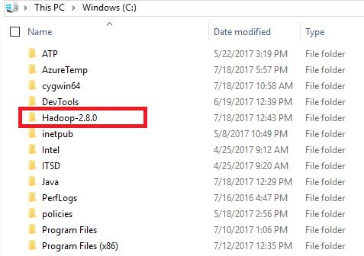

**2.8.0"**

**Set the path HADOOP_HOME Environment variable on windows 10(see Step 1,2,3 and 4 below).**

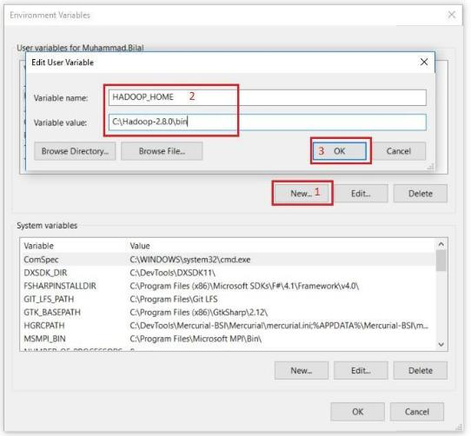

**Set the path JAVA_HOME Environment variable on windows 10(see Step 1,2,3 and 4 below).**

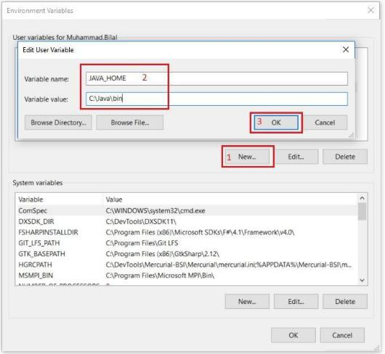

**Next we set the Hadoop bin directory path and JAVA bin directory path.**

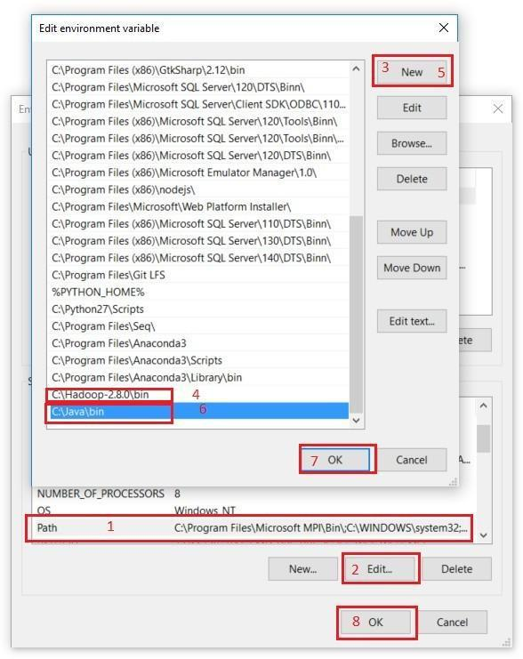

**STEP 3 : Configuration**

Edit file **C:/Hadoop-2.8.0/etc/hadoop/core-site.xml**, paste below xml paragraph and save this file.

<configuration>

<property>

<name>fs.defaultFS</name>

<value>hdfs://localhost:9000</value>

</property>

</configuration>

Rename "mapred-site.xml.template" to "mapred-site.xml" and edit this file **C:/Hadoop-2.8.0/etc/hadoop/mapred-site.xml**, paste below xml paragraph and save this file.

<configuration>

<property>

<name>mapreduce.framework.name</name>

<value>yarn</value>

</property>

</configuration>

Create folder **"data"** under **"C:\Hadoop-2.8.0"**

Create folder **"datanode"** under **"C:\Hadoop-2.8.0\data"**

Create folder **"namenode"** under **"C:\Hadoop-2.8.0\data"**

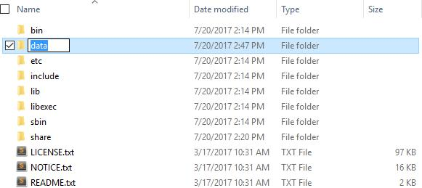

Edit file **C:\Hadoop-2.8.0/etc/hadoop/hdfs-site.xml**, paste below xml paragraph and save this file.

<configuration>

<property>

<name>dfs.replication</name>

<value>1</value>

</property>

<property>

<name>dfs.namenode.name.dir</name>

<value>/hadoop-2.8.0/data/namenode</value>

</property>

<property>

<name>dfs.datanode.data.dir</name>

<value>/hadoop-2.8.0/data/datanode</value>

</property>

</configuration>

Edit file **C:/Hadoop-2.8.0/etc/hadoop/yarn-site.xml**, paste below xml paragraph and save this file.

<configuration>

<property>

<name>yarn.nodemanager.aux-services</name>

<value>mapreduce_shuffle</value>

</property>

<property>

<name>yarn.nodemanager.auxservices.mapreduce.shuffle.class</name>

<value>org.apache.hadoop.mapred.ShuffleHandler</value>

</property>

</configuration>

Edit file **C:/Hadoop-2.8.0/etc/hadoop/hadoop-env.cmd** by closing the command line **"JAVA_HOME=%JAVA_HOME%"** instead of set **"JAVA_HOME=C:\Java"** (OnC:\java this is path to file jdk.18.0)

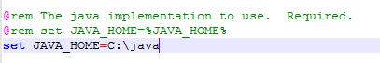

**STEP 4 : Hadoop Configuration**

Dowload file Hadoop Configuration.zip (Link: [https://github.com/MuhammadBilalYar/HADOOP-INSTALLATION-ON- WINDOW-10/blob/master/Hadoop%20Configuration.zip](https://github.com/MuhammadBilalYar/HADOOP-INSTALLATION-ON-WINDOW-10/blob/master/Hadoop%20Configuration.zip))

Delete file bin on C:\Hadoop-2.8.0\bin, replaced by file bin on file just download (from Hadoop Configuration.zip).

Open cmd and typing command **"hdfs namenode –format"** . You will see

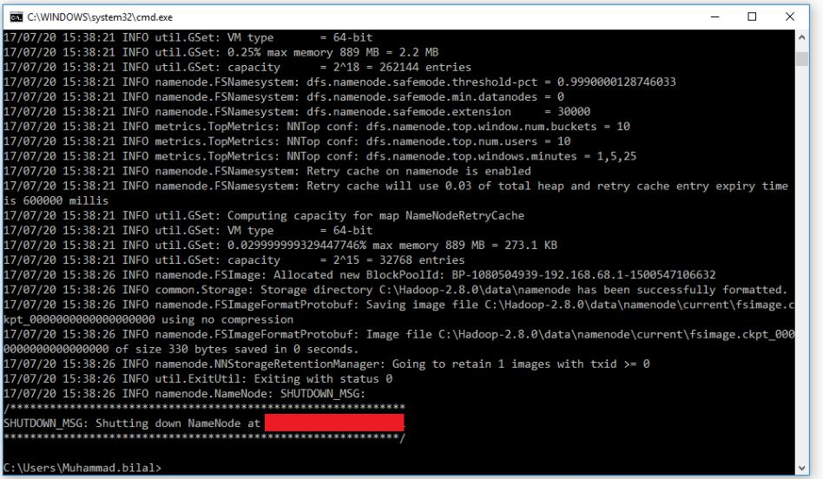

**STEP 5 : Testing**

Open cmd and change directory to "C:\Hadoop-2.8.0\sbin" and type **"start- all.cmd"** to start apache.

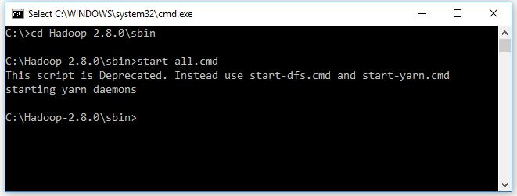

Make sure these apps are running

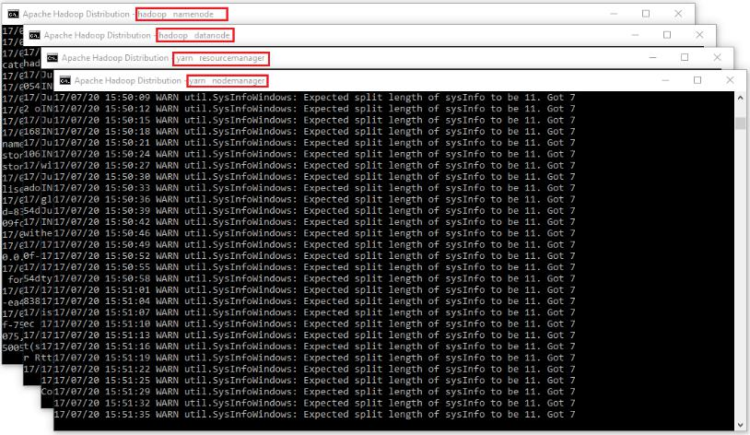

1. Hadoop Namenode
2. Hadoop datanode
3. YARN Resource Manager
4. YARN Node Manager

Open: http://localhost:8088

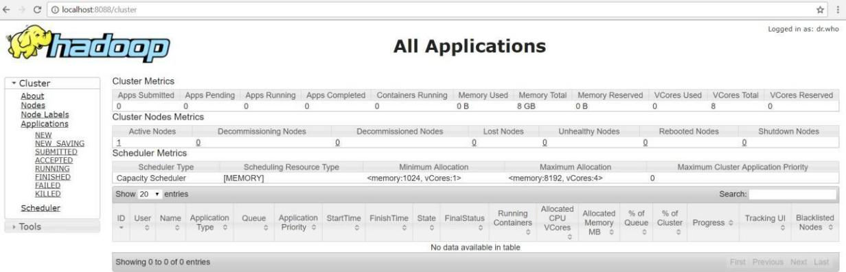

Open: http://localhost:50070

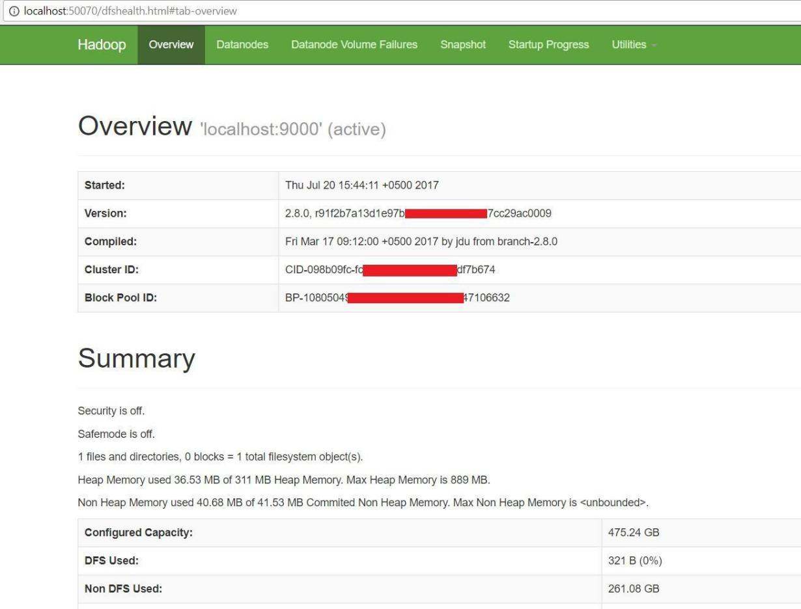

**RESULT:**

Thus, the one node hadoop cluster has been set up successfully.

**WRITE A PROGRAM TO USE THE APIS OF HADOOP TO INTERACT WITH** IT

**EX.NO. : 8**

**AIM:** To write a program to use the API's oh hadoop to interact with it

**PROCEDURE:**

**STEP 1.**

**Prepare**

Download Input_file.txt (Link: <https://github.com/MuhammadBilalYar/HADOOP-INSTALLATION-ON-WINDOW-10/blob/master/input_file.txt>)

Place both files in "C:/"

**STEP 2:**

**Hadoop Operation**

1. Open cmd in Administrative mode and move to "C:/Hadoop-2.8.0/sbin" and start cluster Start-all.cmd

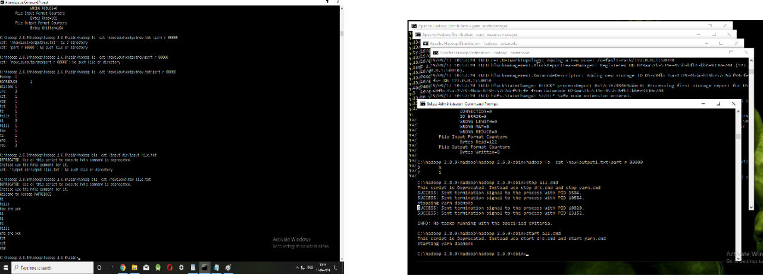

1. Create an input directory in HDFS. hadoop fs -mkdir /input_dir
2. Copy the input text file named input_file.txt in the input directory (input_dir)of HDFS. hadoop fs -put C:/input_file.txt /input_dir
3. Verify input_file.txt available in HDFS input directory (input_dir). hadoop fs -ls /input_dir/
4. Verify content of the copied file.

hadoop dfs -cat /input_dir/input_file.txt

**RESULT: Thus the program to use the apis of hadoop to interact with it are executed successfully**

**WRITE A WORDCOUNT PROGRAM TO DEMONSTRATE THE USE OF MAP AND REDUCE TASKS EX.NO. :9**

**AIM:**

To write a program to use the API's oh hadoopto interact with it and write a wordcount program to demonstate the use of map and reduce task.

**PROCEDURE:**

**STEP 1.**

**Prepare**

Download MapReduceClient.jar (Link:

[https://github.com/MuhammadBilalYar/HADOOP-INSTALLATION-ON-WINDOW-](https://github.com/MuhammadBilalYar/HADOOP-INSTALLATION-ON-WINDOW-10/blob/master/MapReduceClient.jar)

[10/blob/master/MapReduceClient.jar](https://github.com/MuhammadBilalYar/HADOOP-INSTALLATION-ON-WINDOW-10/blob/master/MapReduceClient.jar))

Download Input_file.txt (Link: <https://github.com/MuhammadBilalYar/HADOOP-INSTALLATION-ON-WINDOW-10/blob/master/input_file.txt>)

Place both files in "C:/"

**STEP 2:**

**Hadoop Operation**

Open cmd in Administrative mode and move to "C:/Hadoop-2.8.0/sbin" and start cluster Start-all.cmd

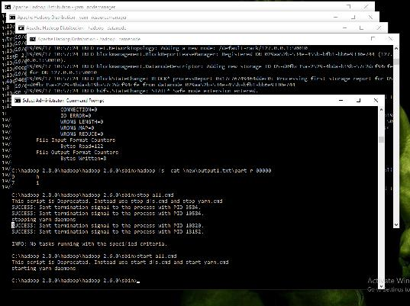

* 1. Create an input directory in HDFS. hadoop fs -mkdir /input_dir
  2. Copy the input text file named input_file.txt in the input directory (input_dir)of HDFS. hadoop fs -put C:/input_file.txt /input_dir

1. Verify input_file.txt available in HDFS input directory (input_dir). hadoop s -ls /input_dir/
2. Verify content of the copied file.

hadoop dfs -cat /input_dir/input_file.txt

Run MapReduceClient.jar and also provide input and out directories.

hadoop jar C:/MapReduceClient.jar wordcount /input_dir /output_dir

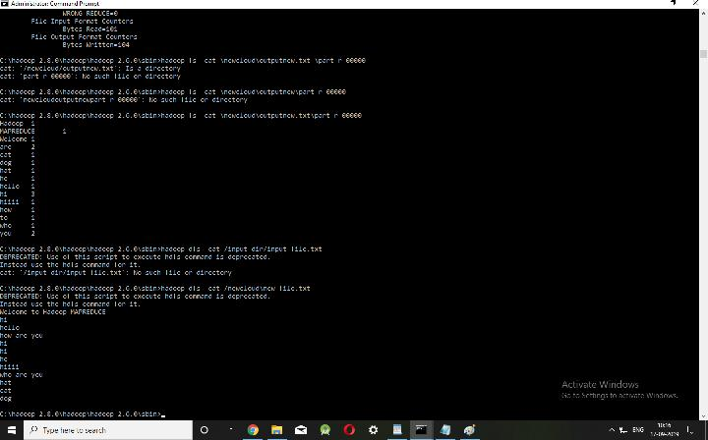

Verify content for generated output file. hadoop dfs -cat /output_dir/*

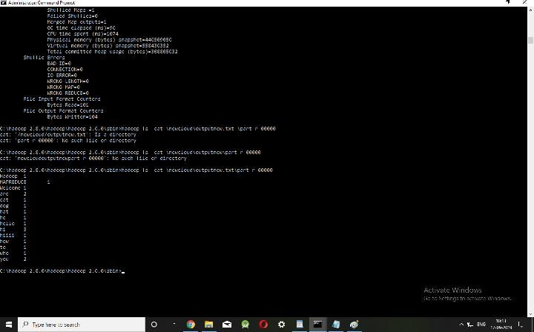

**RESULT: Thus the map and reduce tasks to implement word count in hadoop is executed successfully.**

**WRITE A GREP PROGRAM TO DEMONSTRATE THE USE OF MAP AND REDUCE TASKS**

**EX.NO. : 10**

**AIM: To write a program to use the API"s of hadoop to interact with it and write a grep program to demonstrate**

**the use of map and reduce task**

**PROCEDURE:**

**STEP 1.**

**Prepare**

Download MapReduceClient.jar (Link: <https://github.com/MuhammadBilalYar/HADOOP-INSTALLATION-ON-WINDOW-10/blob/master/MapReduceClient.jar>)

Download Input_file.txt (Link: [https://github.com/MuhammadBilalYar/HADOOP-](https://github.com/MuhammadBilalYar/HADOOP-INSTALLATION-ON-WINDOW-10/blob/master/input_file.txt)

[INSTALLATION-ON-WINDOW-10/blob/master/input_file.txt](https://github.com/MuhammadBilalYar/HADOOP-INSTALLATION-ON-WINDOW-10/blob/master/input_file.txt))

Place both files in "C:/"

**STEP 2:**

**Hadoop Operation**

Open cmd in Administrative mode and move to "C:/Hadoop-2.8.0/sbin" and start cluster Start-all.cmd Create an input directory in HDFS. hadoop fs

-mkdir /input_dir

Copy the input text file named input_file.txt in the input directory (input_dir)of HDFS. hadoop fs -put C:/input_file.txt /input_dir

Verify input_file.txt available in HDFS input directory (input_dir).

hadoop fs -ls /input_dir/

Verify content of the copied file.

hadoop dfs -cat /input_dir/input_file.txt

Run MapReduceClient.jar and also provide input and out directories. hadoop jar "C:/MapReduceClient.jar"

grep /input_dir /output1_dir "hi"

Verify content for generated output file. hadoop dfs -cat /output1_dir/*

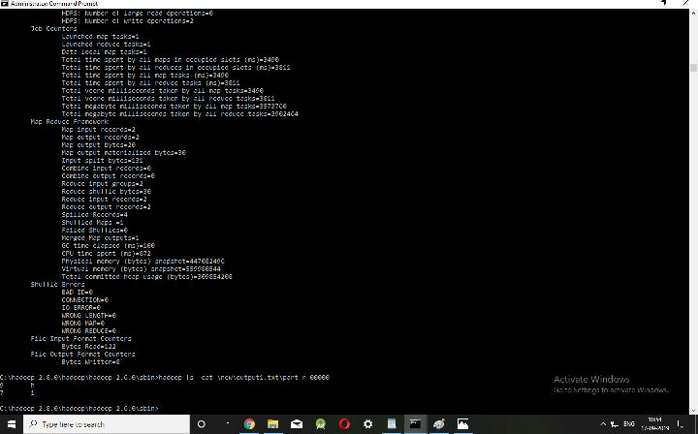

**RESULT: Thus the map and reduce tasks to implement grep in hadoop is executed successfully**